5 Design and develop a discrete-event model that will simulate process by:

• Creating a simple model

• Adding resources

• Creating 3D animation

• Modeling delivery

[Use a case situation like a company’s manufacturing and shipping].

Create a new model. In the **New Model** wizard, set the **Model name**: Job Shop,

and **Model time units**: **minutes**.

**2.** Open the **Presentation** palette. The palette has several shapes that you can

use to draw model animation, including a rectangle, a line, an oval, a polyline

and a curve.

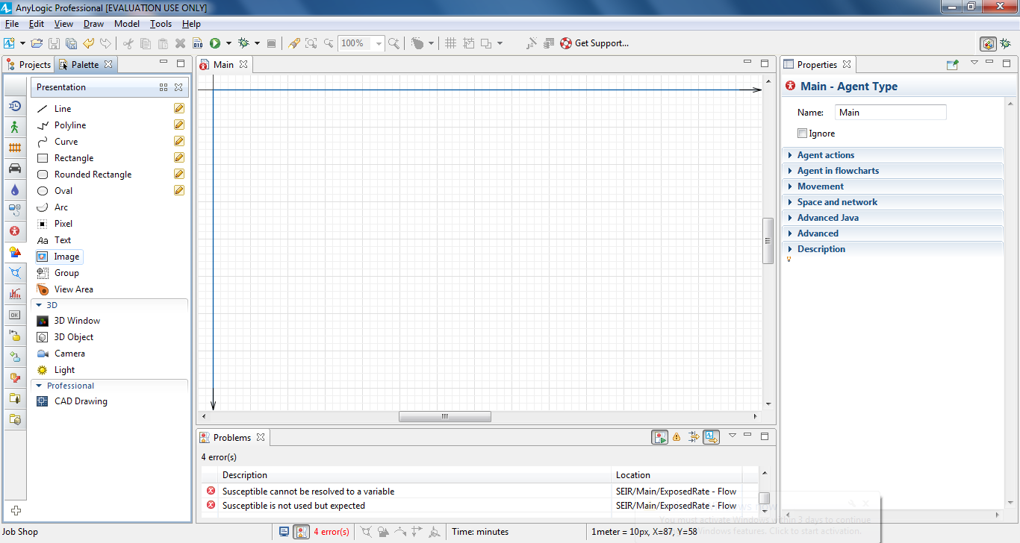

On the **Presentation** palette, select the **Image** shape and then drag it on to

the Main diagram. You can use the **Image** shape to add images in several

graphic formats -- including PNG, JPEG, GIF, and BMP – to your presentation.

You’ll see the dialog box that prompts you to choose the image file the shape

will display.

**5.** Browse to the following location and then select the layout.png image:

AnyLogic folder/resources/AnyLogic in 3 days/Job Shop

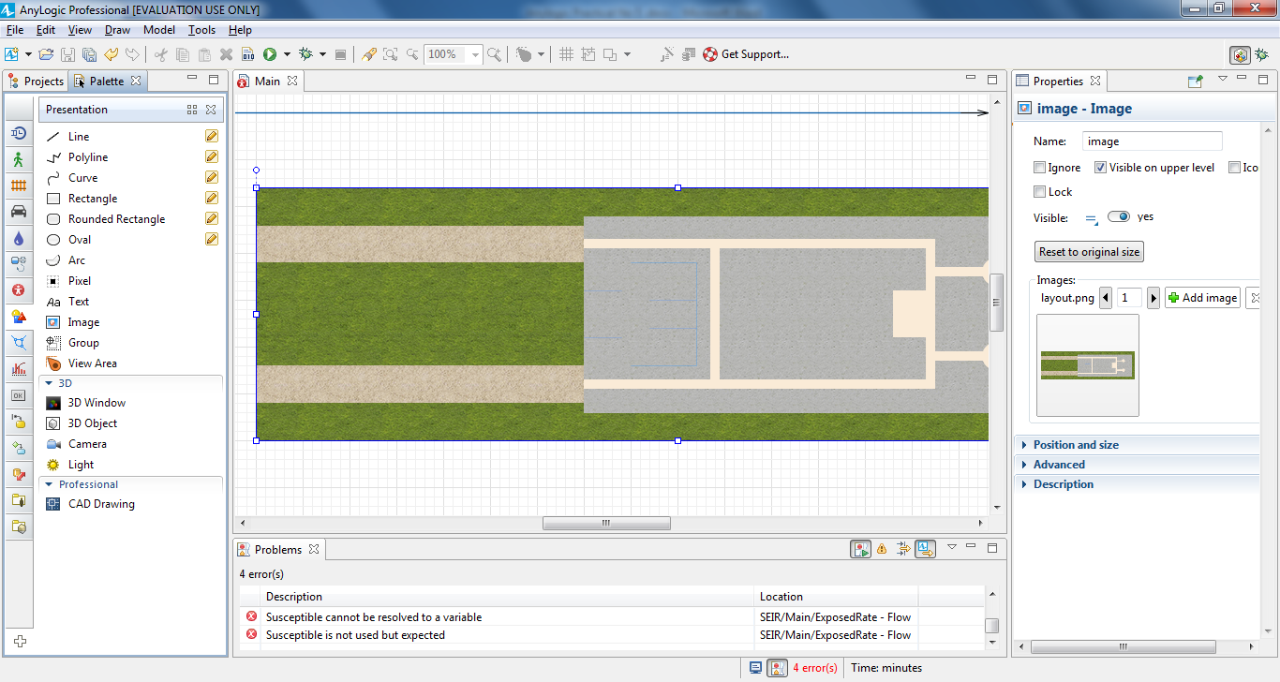

Select the image in the graphical editor. In the **Properties** view, select the **Lock**

checkbox to lock the image.

Open the **Space Markup** palette, and drag the **Rectangular Node** element on

to the Main diagram. Resize the node. The node should look as in the figure

below.

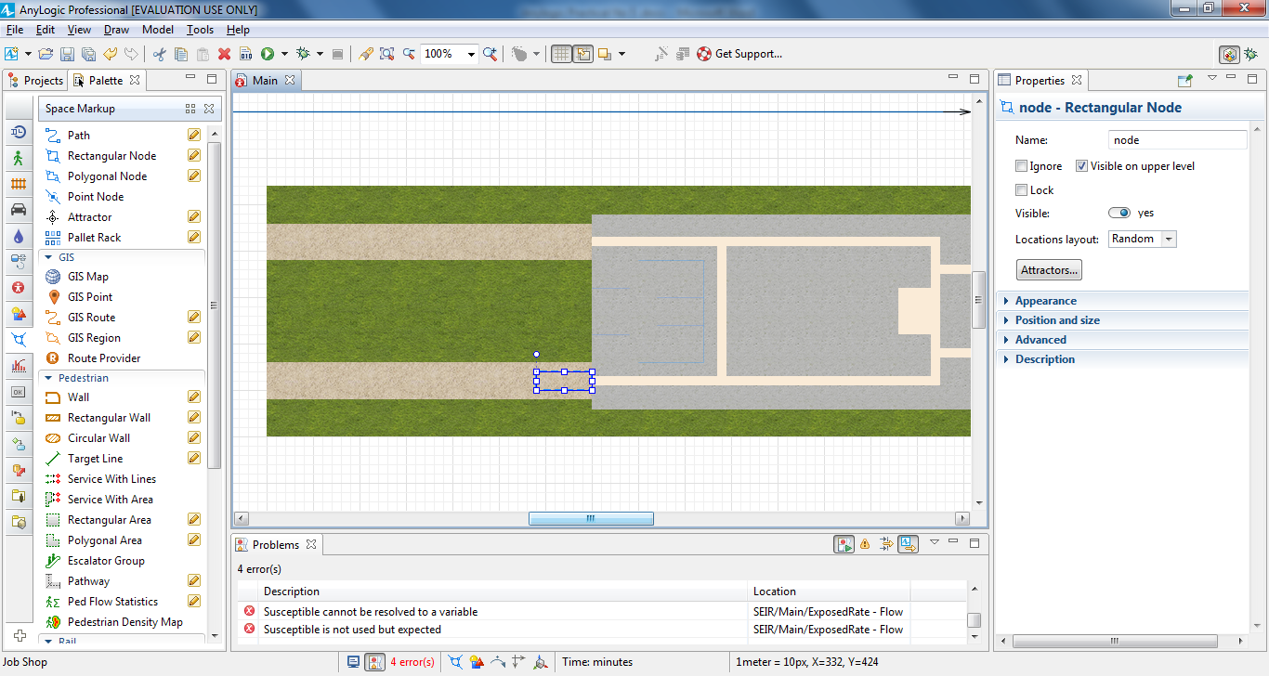

Name the created node receivingDock.

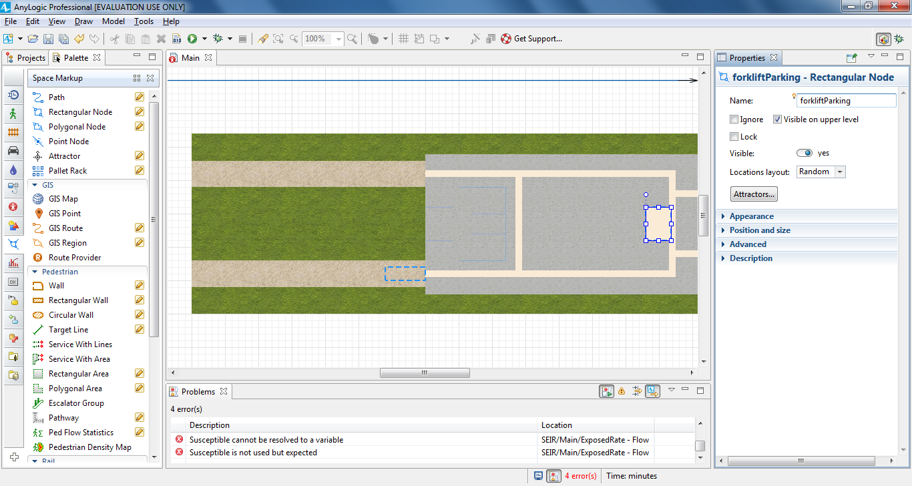

Use another **Rectangular Node** to draw the parking area as shown

in the figure below and then name this node forkliftParking.

Do the following to draw a movement path that will guide our model’s forklift

trucks:

In the **Space Markup** palette, double-click the **Path** element to

activate its drawing mode.

b. Draw the path as shown in the figure below by clicking the

receivingDock border, clicking in the diagram to add the path’s

turning point, and then clicking the forkliftParking node’s border.

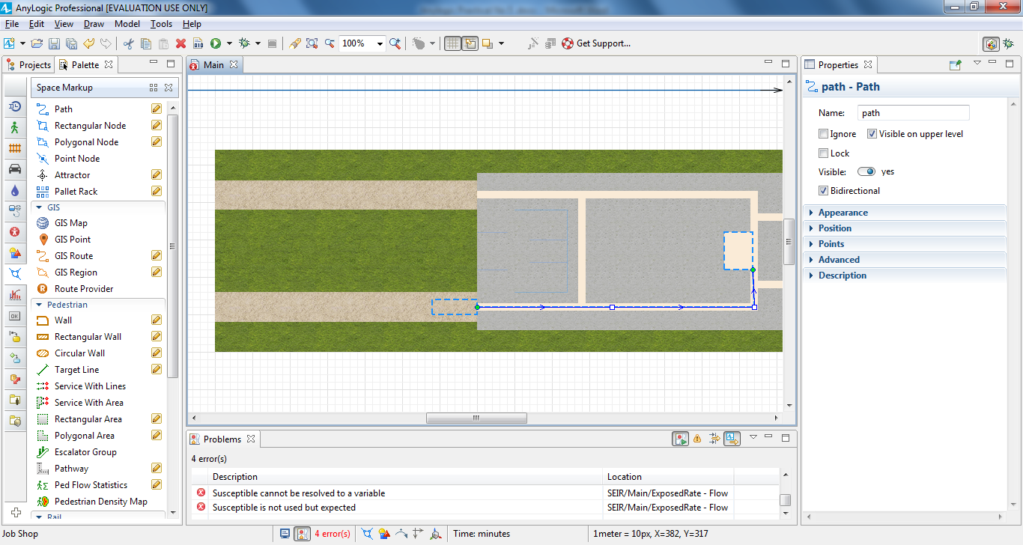

If you’ve successfully connected the nodes, the path’s connection points will display cyan highlights each time you select the path.

Define your model’s warehouse storage by dragging the **Pallet Rack**

element from the **Space Markup** palette on to the layout and placing its aisle

on the path. A correctly-placed pallet rack will display a green highlight that

shows it is connected to the network.

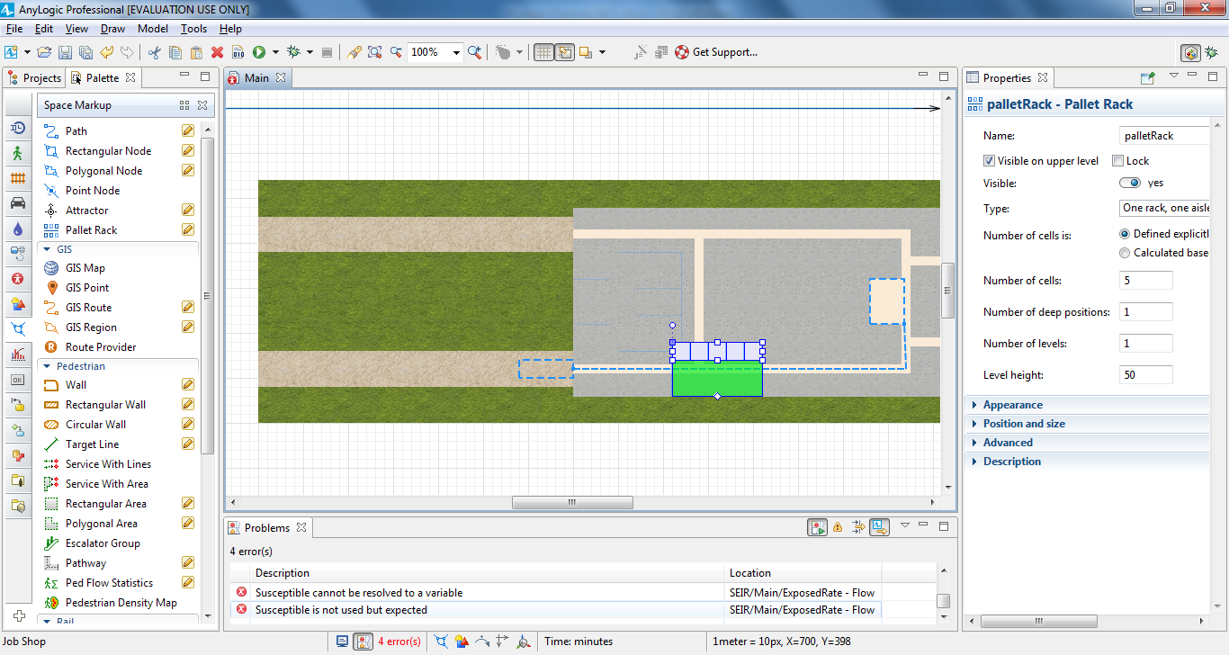

In the pallet rack’s **Properties** area, do the following:

a. Set **Type** to: two racks, one aisle

b. **Number of cells**: 10

c. **Level height**: 10

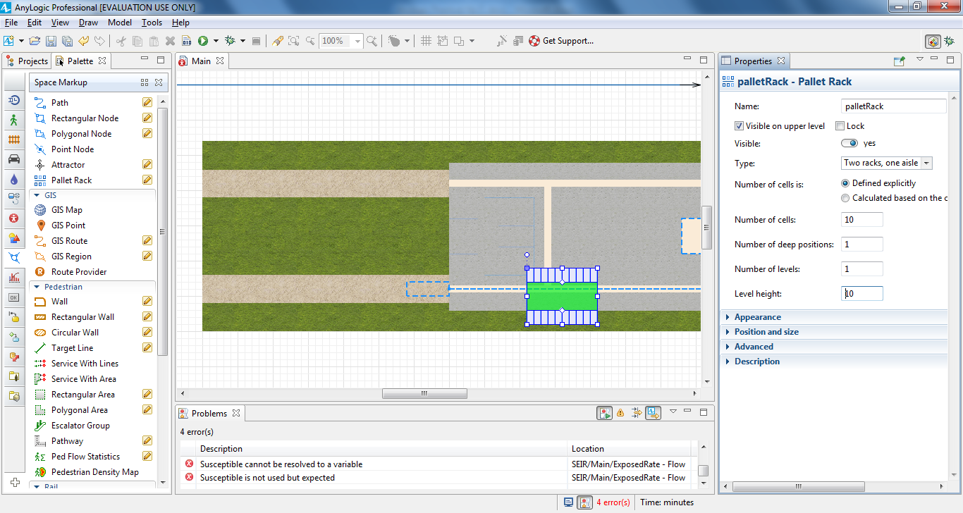

In the **Position and size** section:

d. **Length**: 160

e. **Left pallet rack depth**: 14

f. **Right pallet rack depth**: 14

g. **Aisle width**: 11

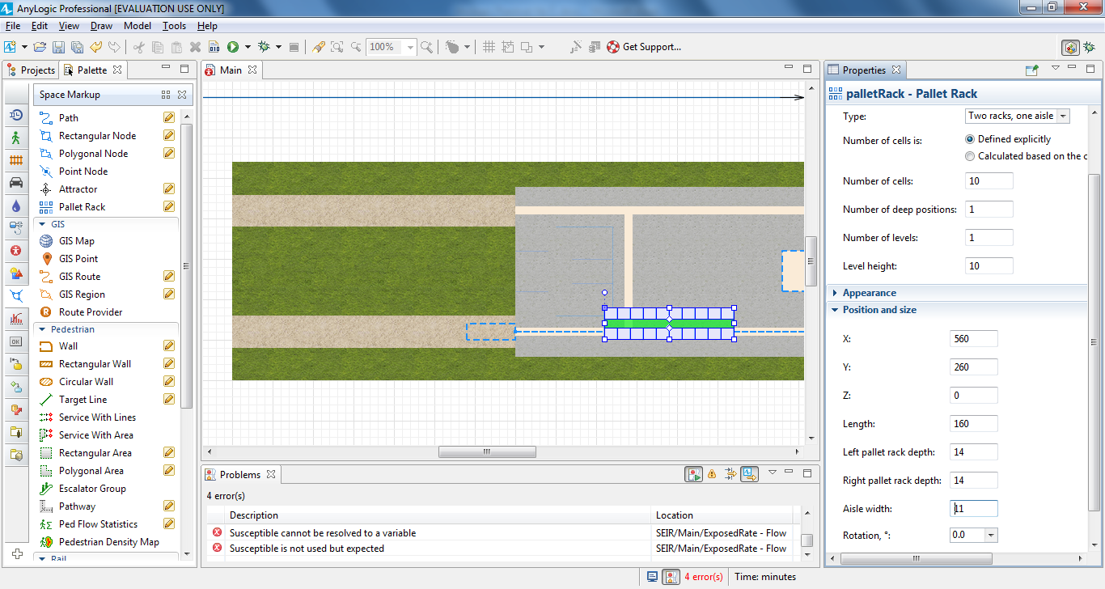

After you’ve completed these changes, the pallet rack should resemble the

pallet rack shown in the figure below. If necessary, move the pallet rack so

that its center aisle lies on the path. Make sure the pallet rack is connected to

the network by clicking it twice to select it. Your first click will select the

entire network, and the second will select the pallet rack. The pallet rack

should display a green highlight that shows it is connected to the network.

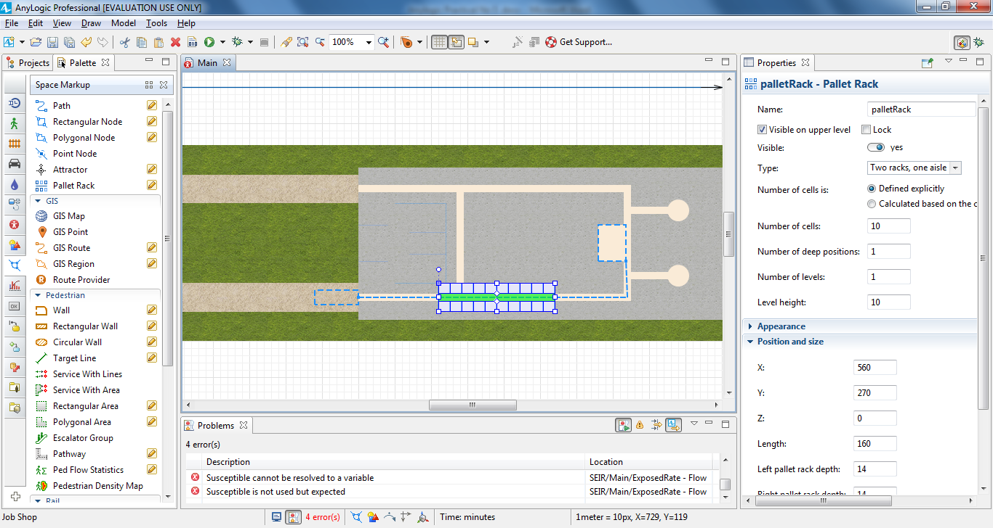

Drag the **Source** element from the **Process Modeling Library** palette on

to the graphical diagram and name the block sourcePallets.

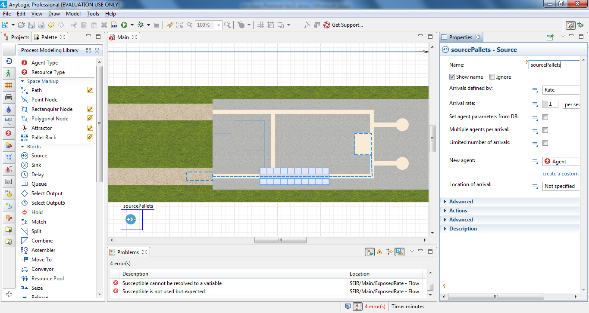

While the **Source** block usually acts as a process starting point, our model will

use it to generate pallets.

In the sourcePallets block’s **Properties** area, do the following to ensure the

model’s pallets arrive every five minutes and appear in the receivingDock

node.

a. In the **Arrivals defined by** area, click **Interarrival time**.

b. In the **Interarrival time** box, type 5, and select **minutes** from the list on

the right to have pallets arrive every five minutes.

c. In the **Location of arrival** area, click **Network / GIS node** in the list.

d. In the **Node** area, click receivingDock in the list.

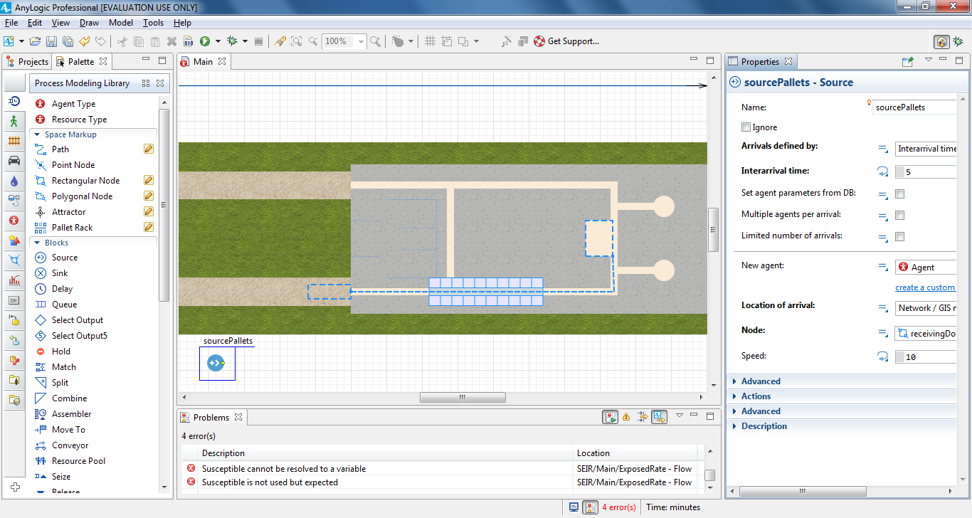

Drag the **RackStore** block from the **Process Modeling Library** palette on to

the diagram and place it near the sourcePallets block so they are

automatically connected as shown in the diagram below.

The **RackStore** block places pallets into a given pallet rack’s cells.

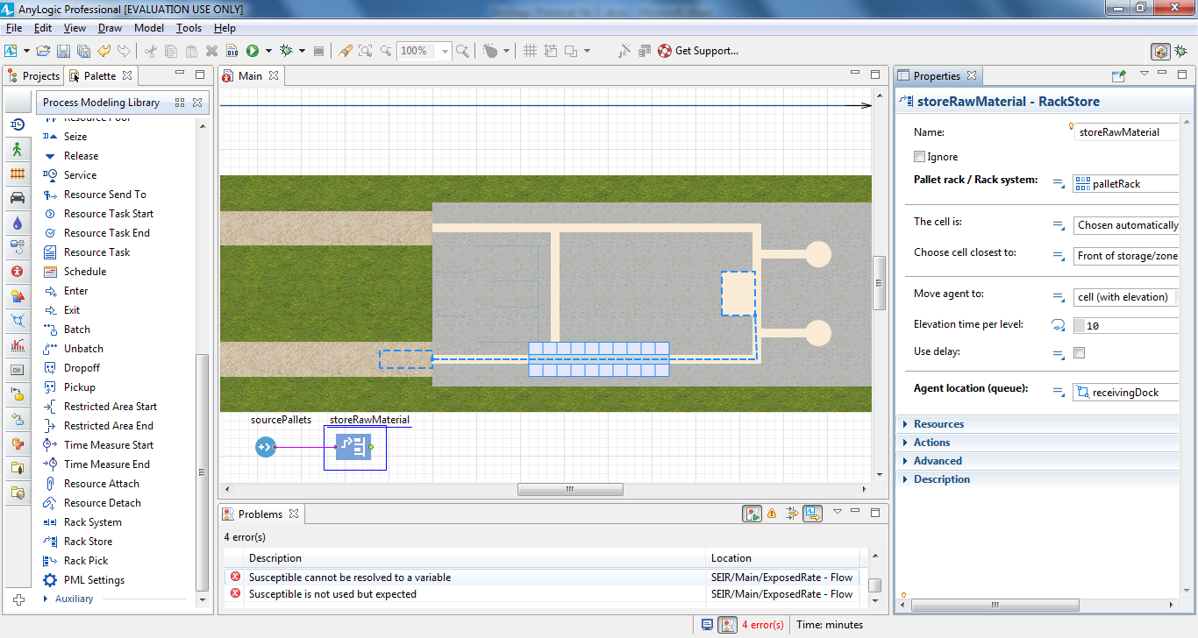

In the rackStore block’s **Properties** area, do the following:

a. In the **Name** box, type storeRawMaterial.

b. In the **Pallet rack / Rack system** list, click palletRack.

c. In the **Agent location (queue)** list, click receivingDock to specify the

location where agents wait to be stored.

Add a **Delay** block to simulate how pallets wait in the rack and then name

the block rawMaterialInStorage.

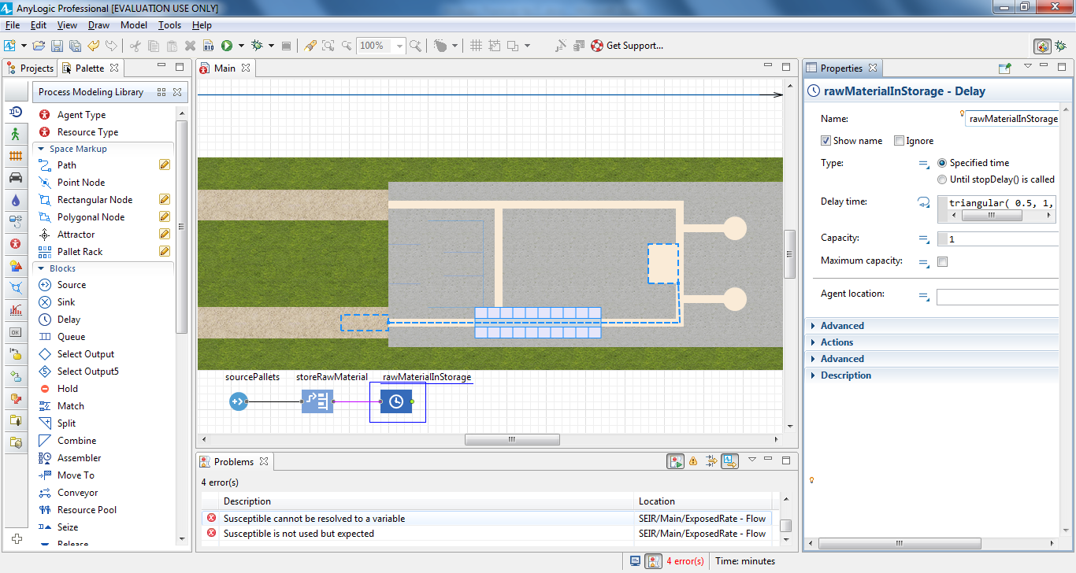

In the rawMaterialInStorage block’s **Properties** area, do the following:

a. In the **Delay time** box, type triangular(15, 20, 30) and select **minutes**

from the list.

b. Select the **Maximum capacity** checkbox to ensure agents will not get

stuck as they wait to be picked up from storage.

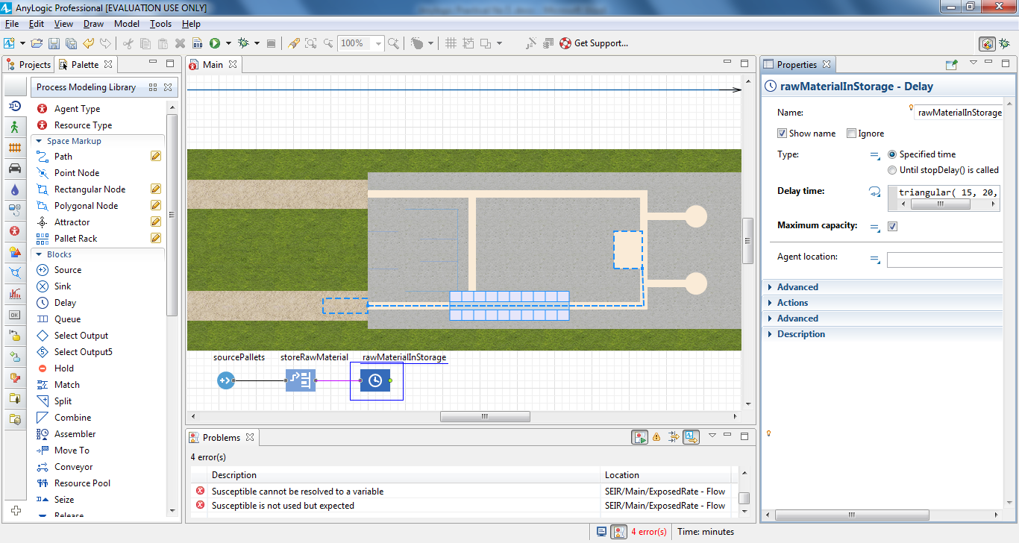

Add a **RackPick** block, connect it to the flowchart, and then name it

pickRawMaterial.

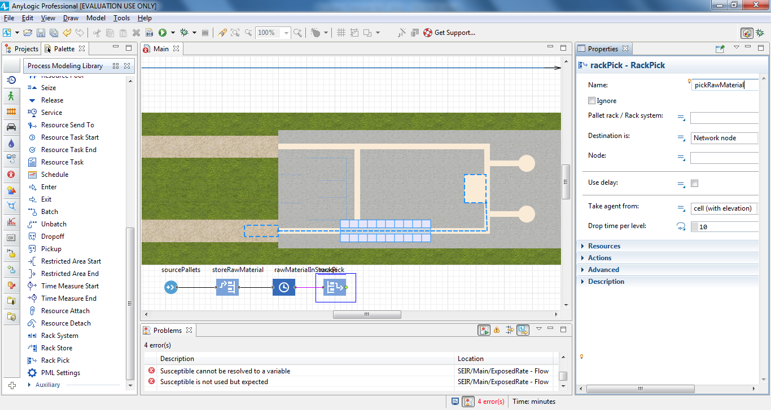

In the pickRawMaterial block’s **Properties** area, do the following:

a. In the **Pallet rack / Rack system** list, click palletRack to select the

pallet rack that will provide pallets to agents.

b. In the **Node** list, click forkliftParking to specify where the agents

should park forklift trucks.

Add a **Sink** block. The **Sink** block disposes agents and is usually a

flowchart's end point.

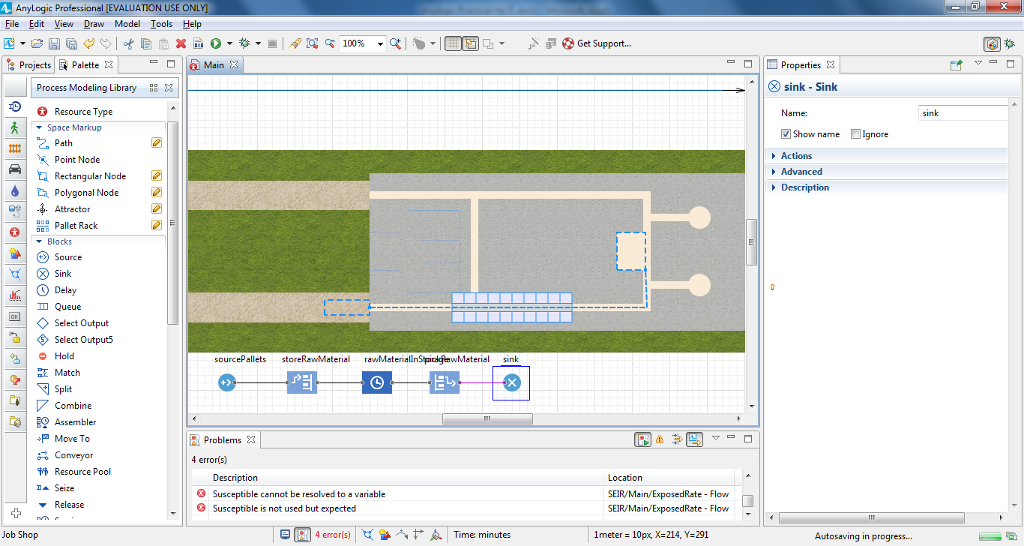

Run the model (Job Shop / Simulation experiment).

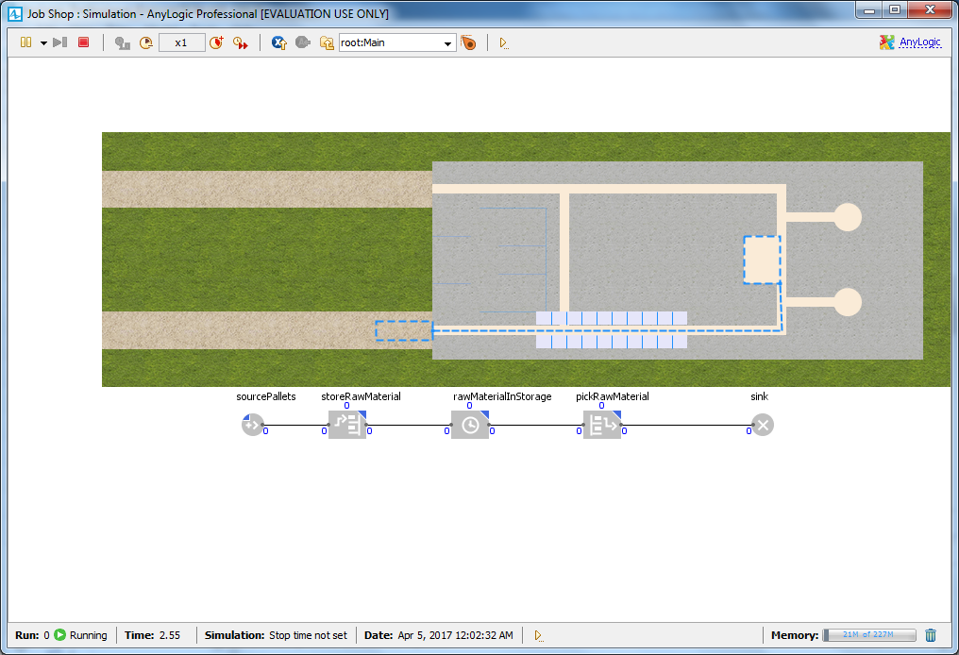

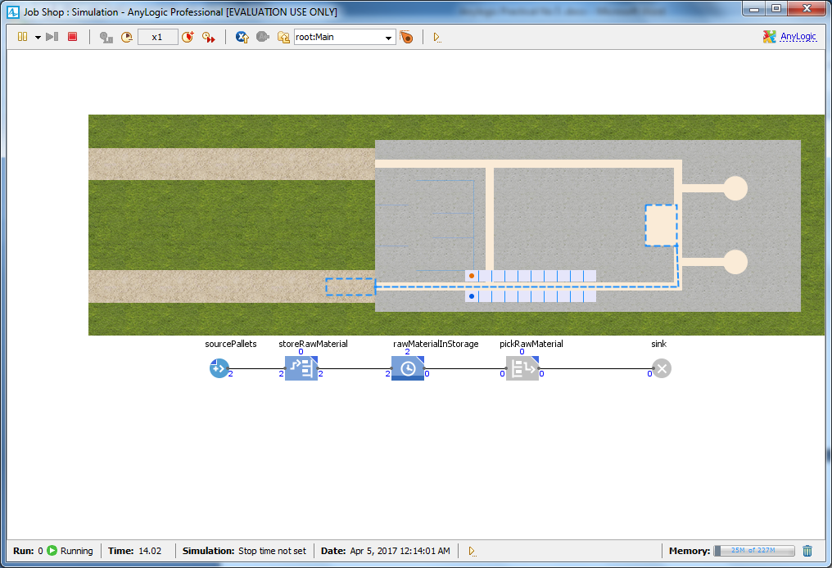

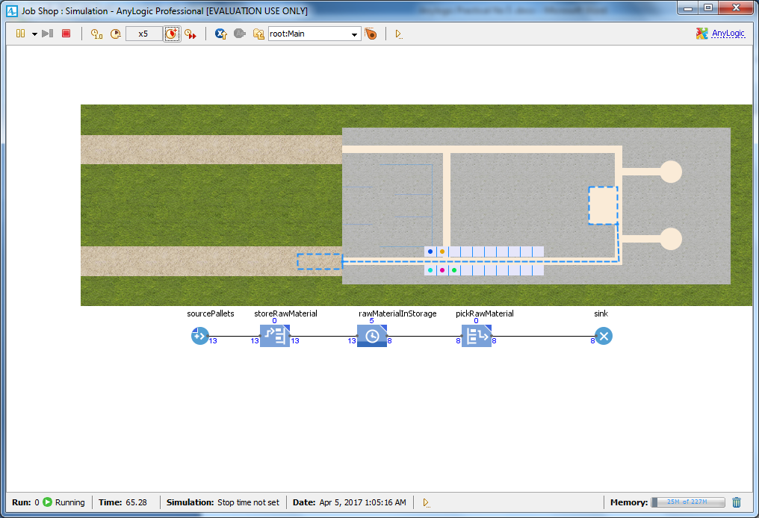

Adding resources

Some examples of resources include:

• A hospital model’s doctors, nurses, equipment, and wheelchairs

• A supply chain model’s vehicles and containers

• A warehouse model’s forklift trucks and workers

There are three types of resources: *static*, *moving*, and *portable*.

• Static resources are bound to a specific location, and they cannot move or be

moved.

• Moving resources can move independently.

• Portable resources can be moved by agents or by moving resources.

Our model’s resources are the forklift trucks that move pallets from the unloading

zone to a pallet rack and then deliver pallets from the rack to the production zone.

On the **Process Modeling Library** palette, drag the **ResourcePool** block

on to the Main diagram. You do not have to connect the block to the flowchart.

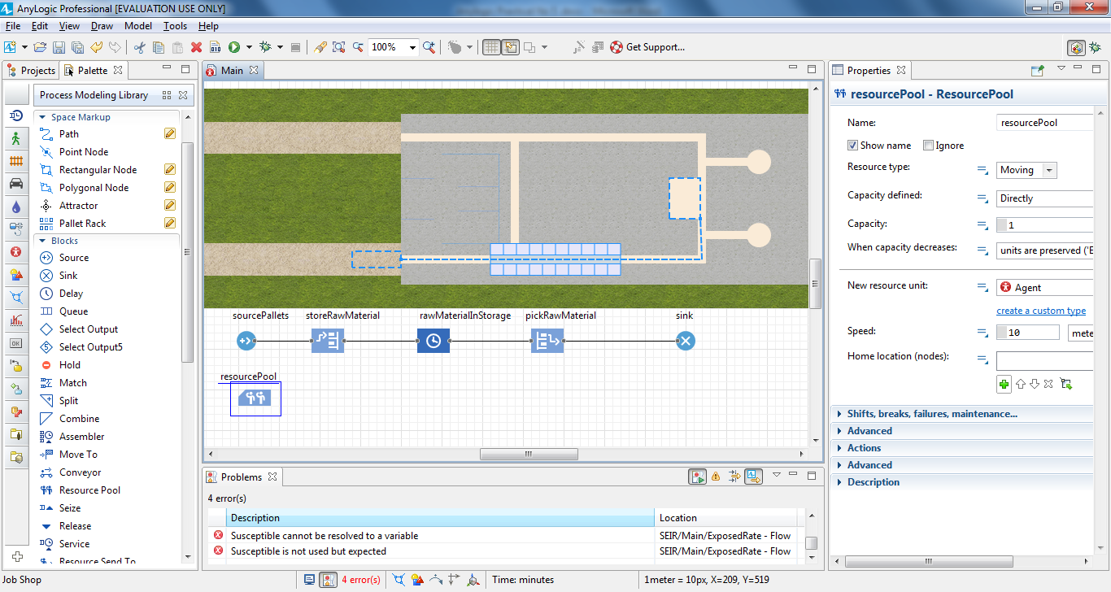

Name the **ResourcePool** block forklifts

In the forklifts block’s **Properties** area, in the new resource unit->click the button **create a custom type**.

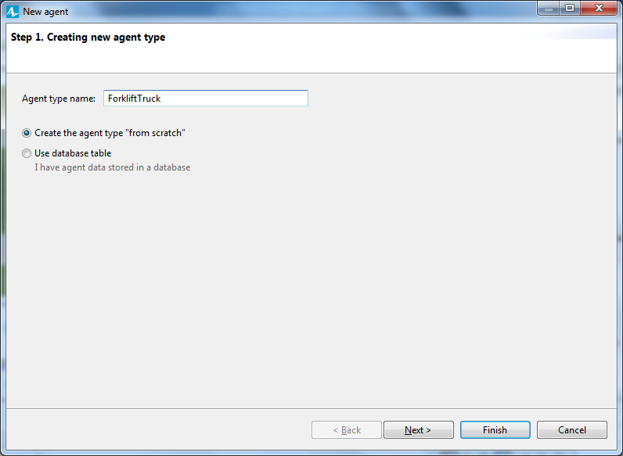

In the **New agent** wizard:

a. In **Agent type name** box, type ForkliftTruck.

b. Click **Next**.

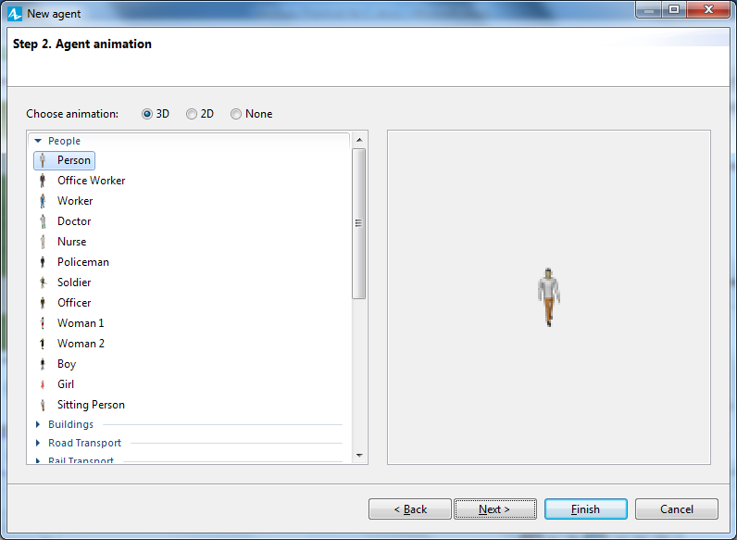

expand the

**Warehouses and Container Terminals** area,

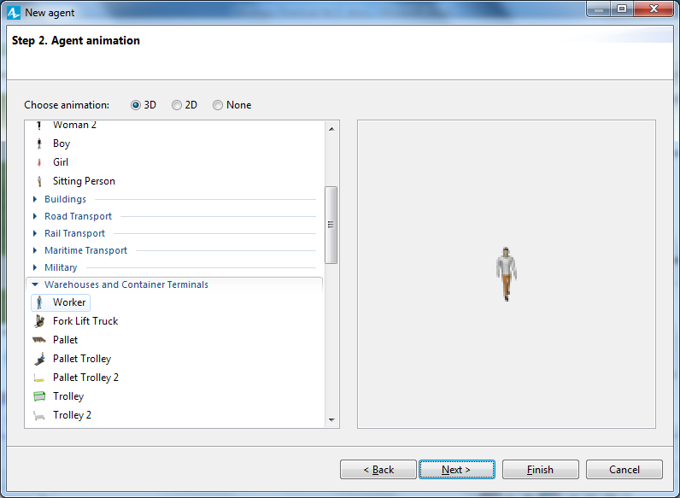

and then click the 3D animation figure **Fork Lift Truck**.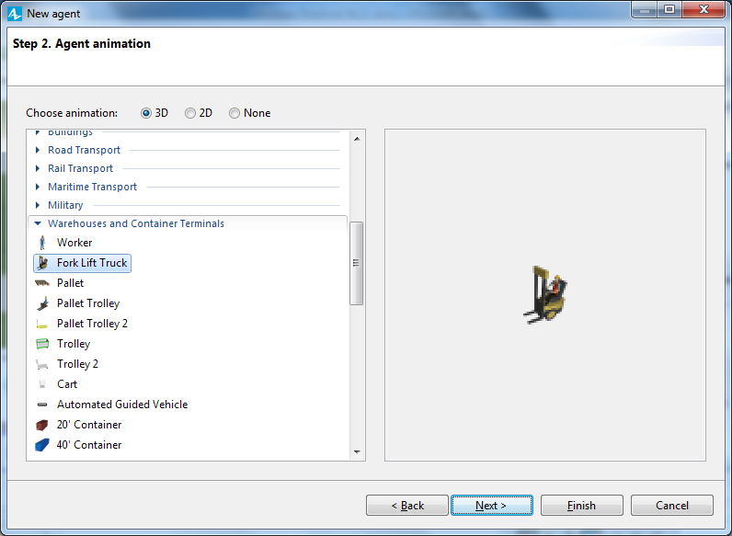

Click **Finish**.

The ForkliftTruck agent type diagram will open and display the animation

shape you selected in the wizard.

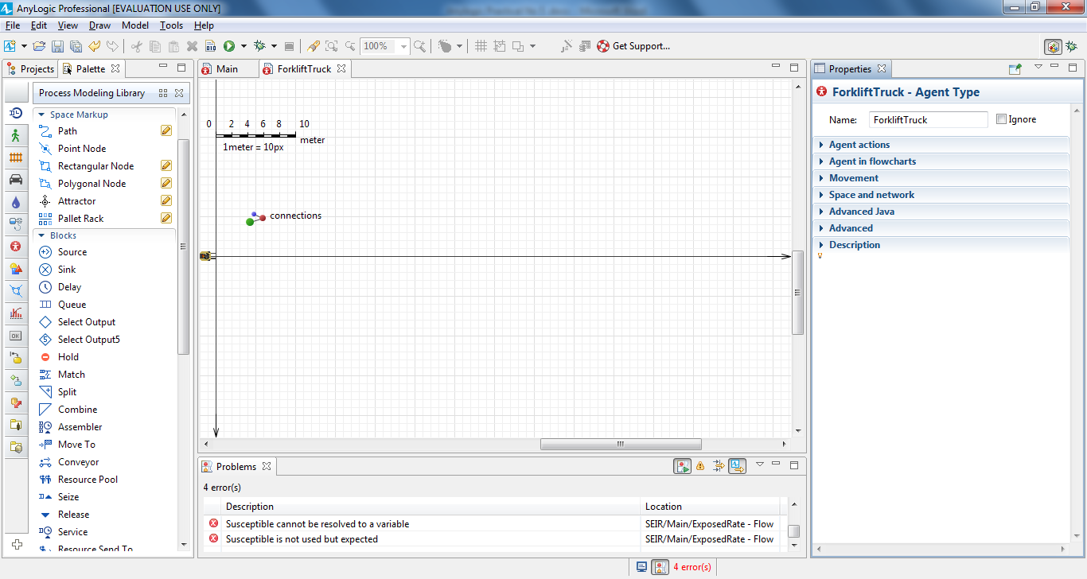

You’ll see the ForkliftTruck resource type has been selected in the

**ResourcePool** block’s **New resource unit** parameter.

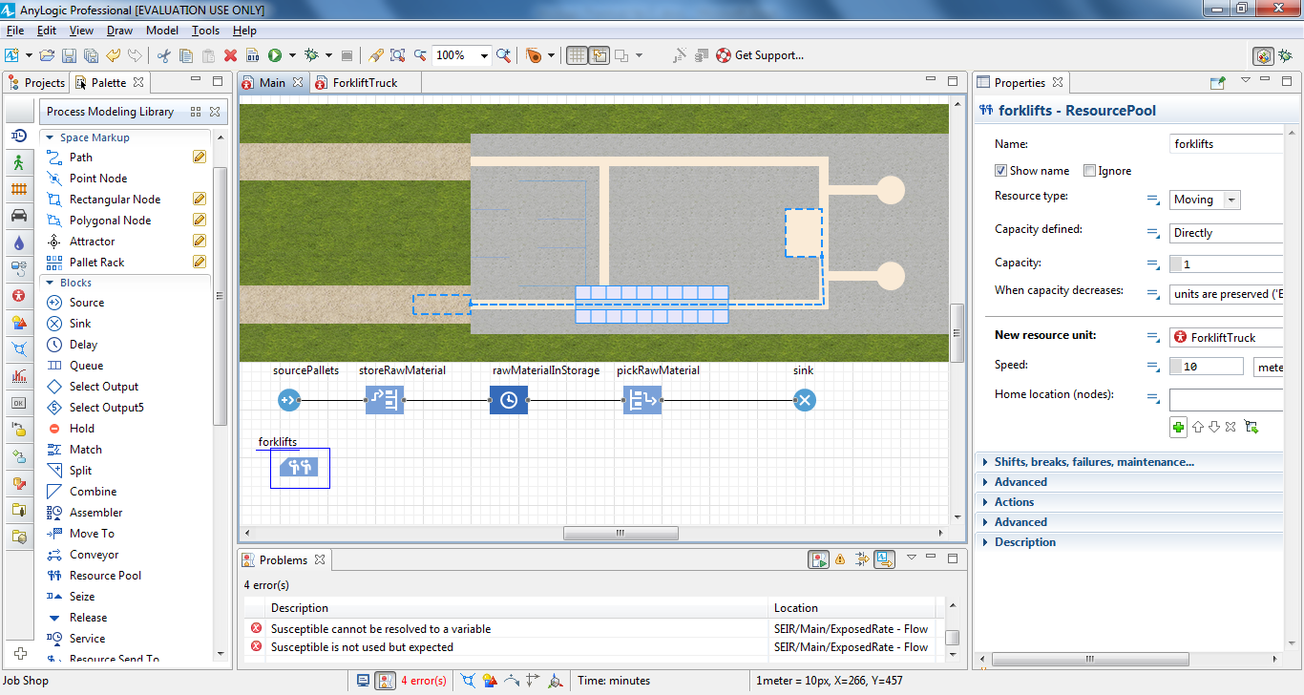

Modify the forklifts resource type’s other parameters:

In the **Capacity** box, type **5** to set the number of forklift trucks in our

model.

b. In the **Speed** box, type **1** and choose **meters per second** from the list

on the right.

c. In the **Home location (nodes)** area, select the forkliftParking node.

Click the plus button and then click **forkliftParking** in the list of

the model’s nodes.

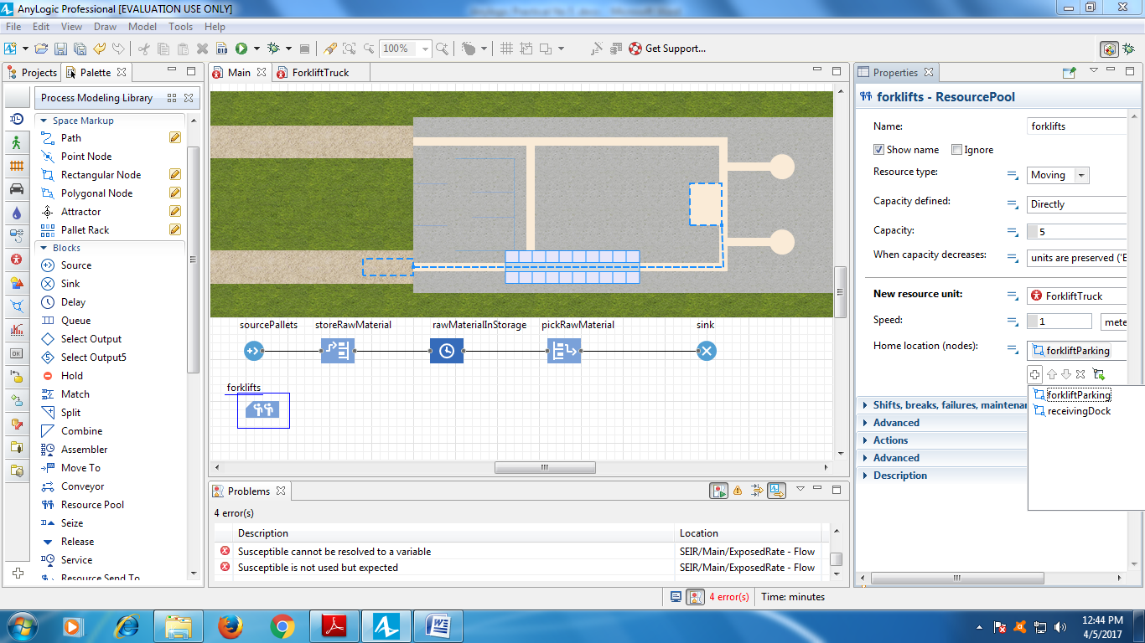

In the storeRawMaterial block’s **Properties** area, do the following:

a. Click the arrow to expand the **Resources** area.

b. Select the **Use resources to move** check box.

c. In the **Resource sets (alternatives)** list, select **forklifts** to ensure the

flowchart block uses the selected resources -- in our case, the forklift

trucks -- to move the agents. Click the plus button and then click

**forklifts** in the list of the model’s resources.

d. In the **Return home** area, select **if no other tasks** to ensure the forklift

trucks return to their home location after they complete their tasks.

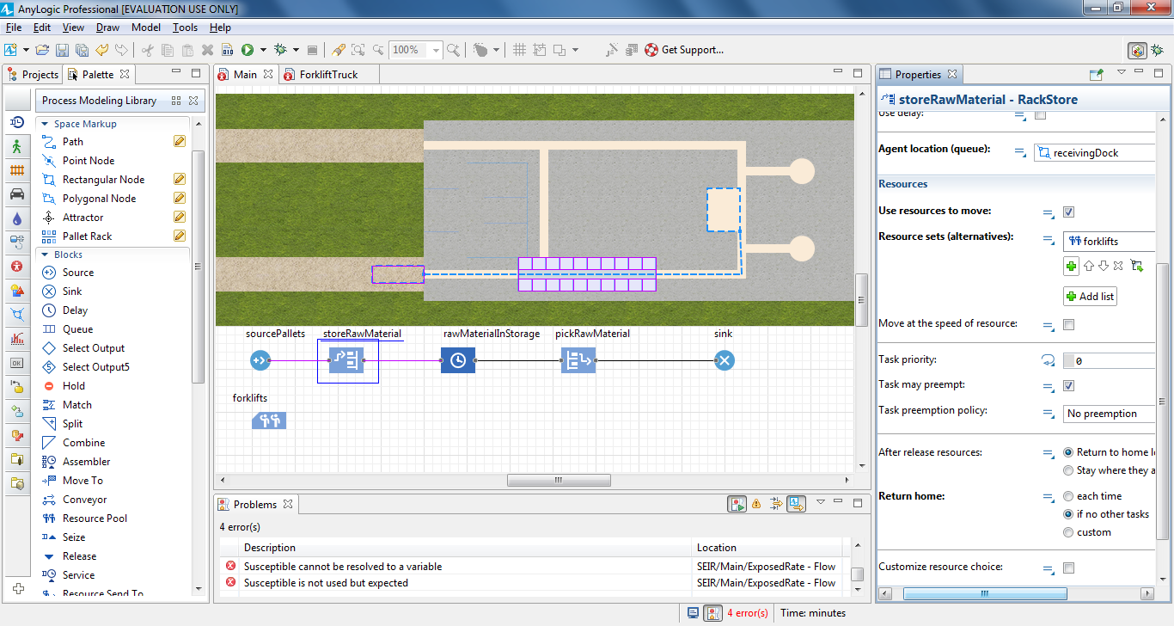

In the pickRawMaterial block’s **Properties** area, do the following:

a. Click the arrow to expand the **Resources** area.

b. Select the **Use resources to move** check box.

c. In the **Resource sets (alternatives)** list, click **forklifts** to ensure the

flowchart block uses the forklift trucks to move the agents.

d. In the **Return home** area, click **if no other tasks** to ensure the forklift

trucks return to their home location after they complete their tasks.

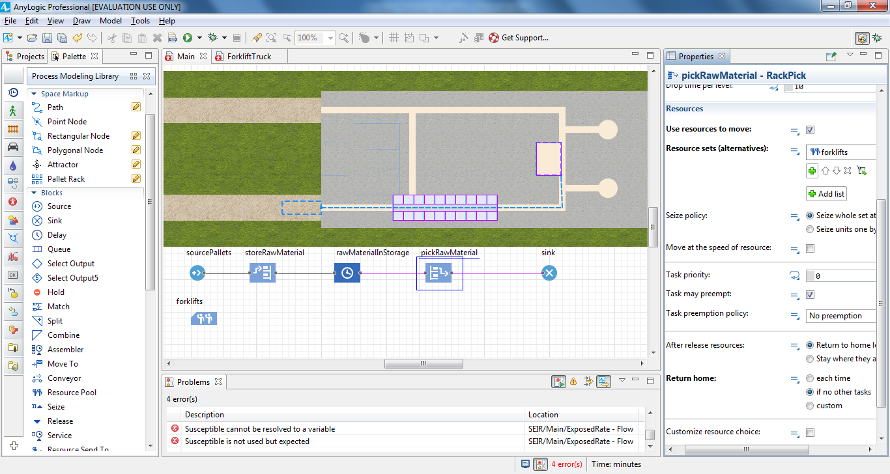

Run the model.

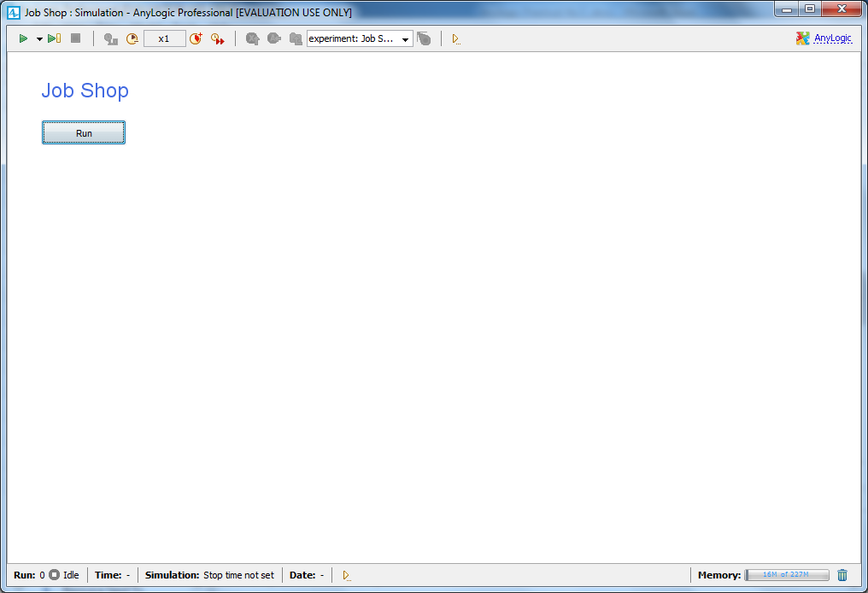

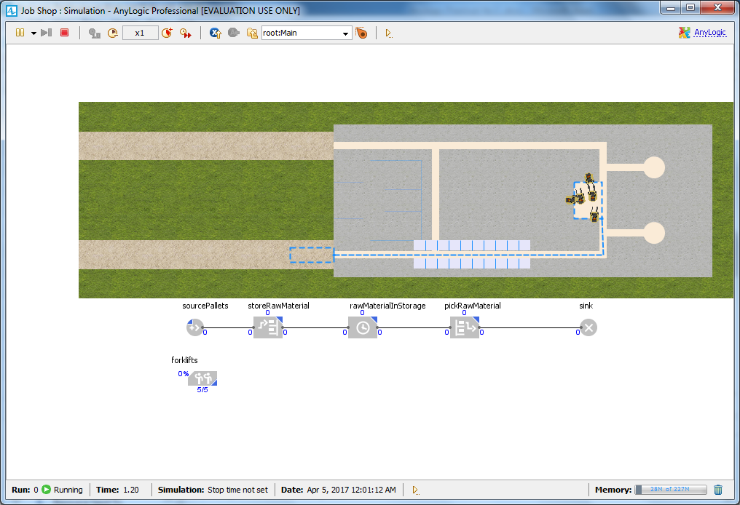

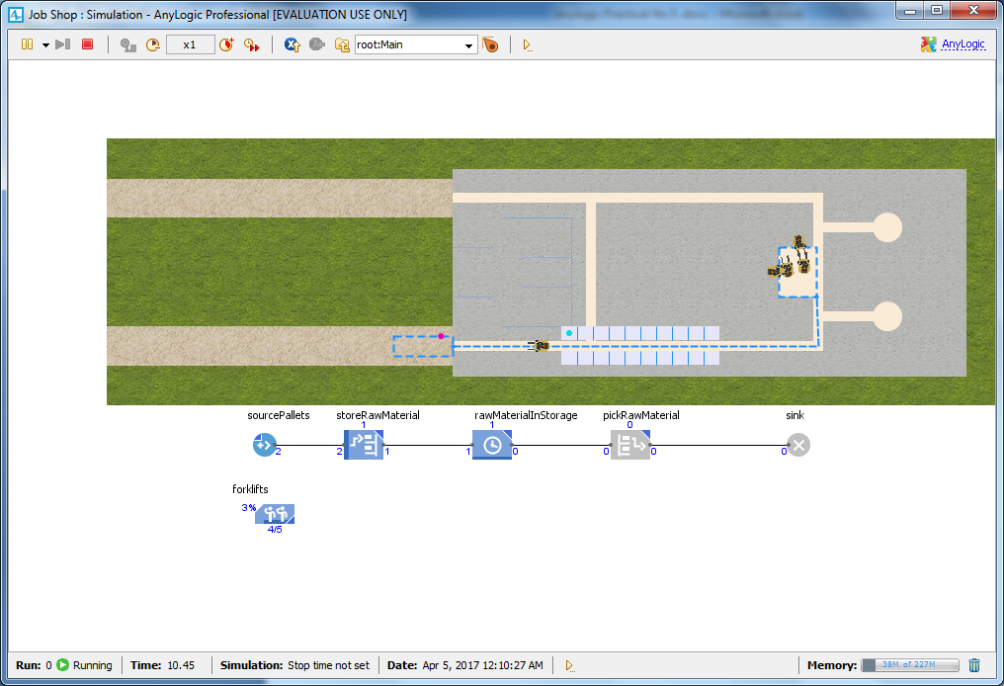

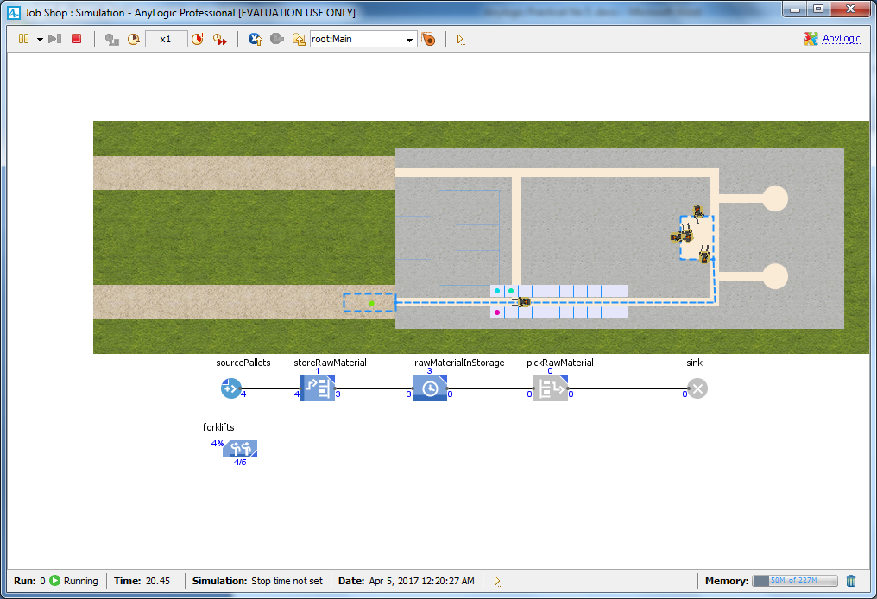

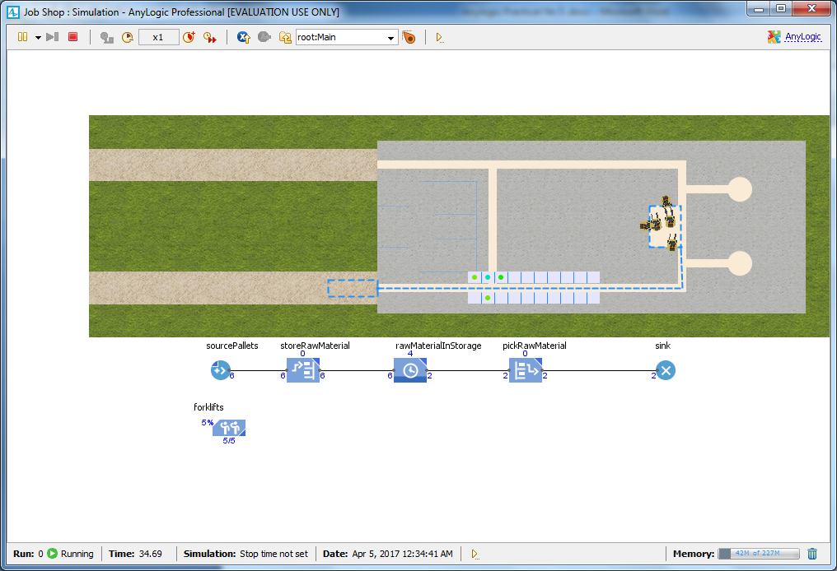

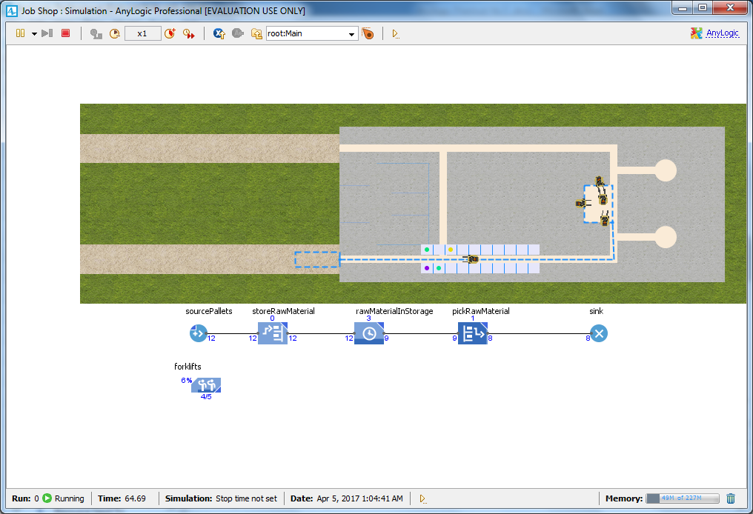

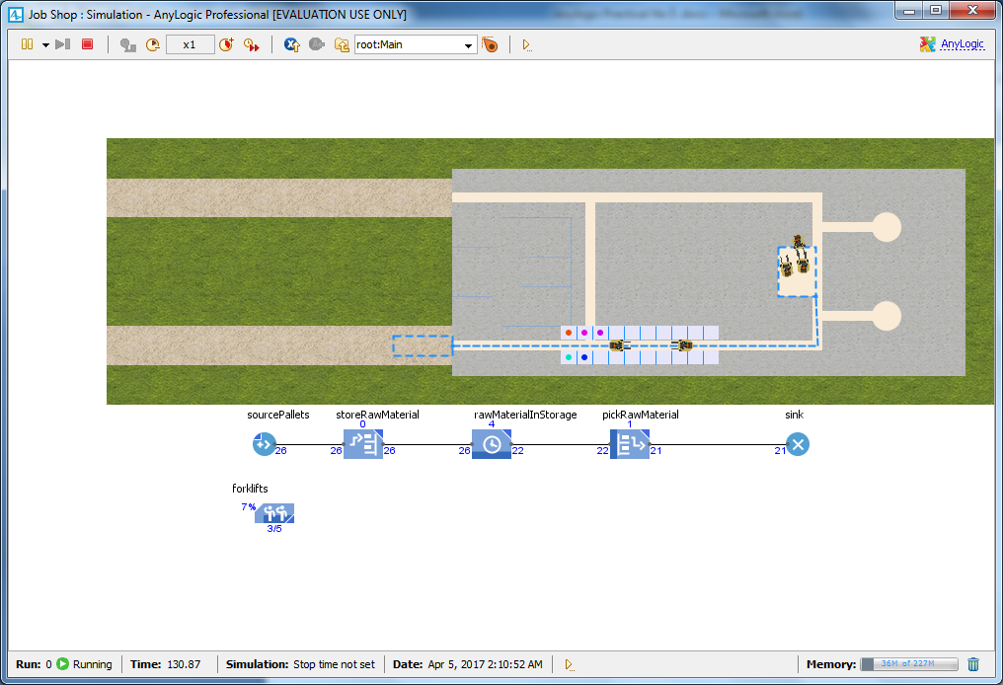

**Creating 3D animation**

On the **Presentation** palette, drag the **Camera** object on to the Main

diagram so it faces the job shop layout.

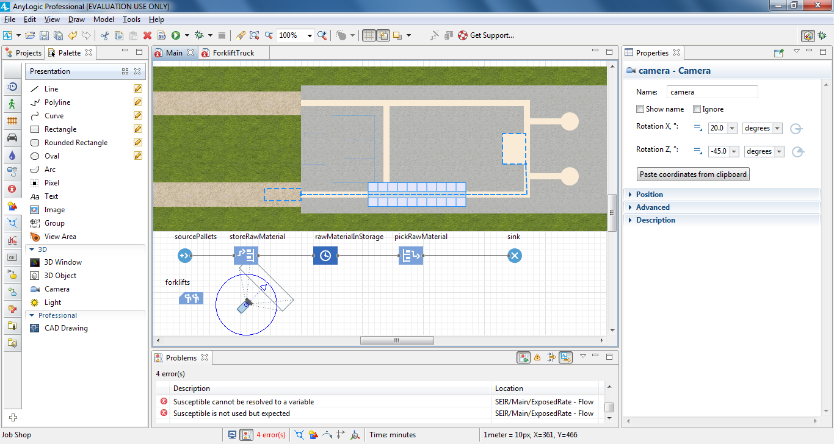

Drag the **3D Window** element on to the Main diagram, and then place it

below the process flowchart.

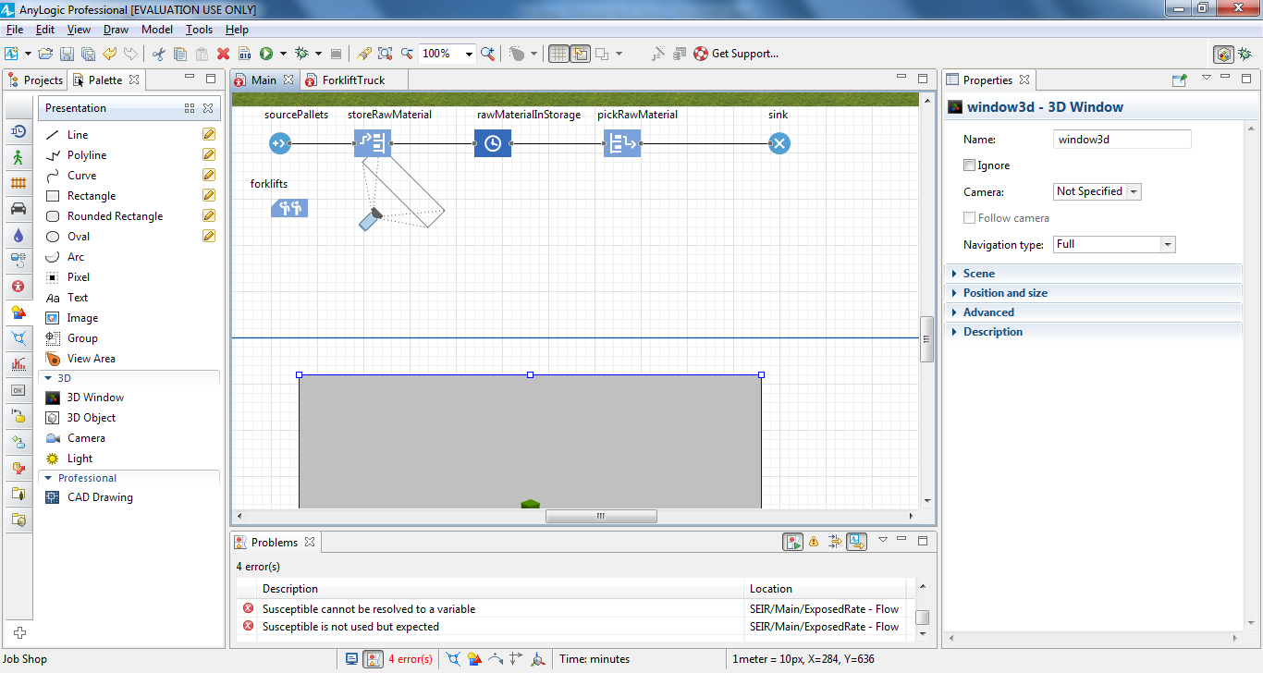

Let the camera “shoot” the picture for the 3D window. In the 3D window’s

**Properties** area, click **camera** in the **Camera** list.

**4.** Prevent the camera from shooting the picture from under the floor by

selecting the option **Limited to Z above 0** from the **Navigation type** list.

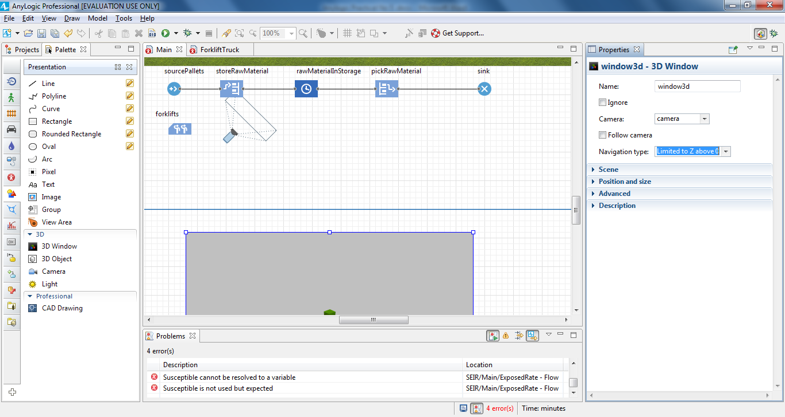

Run the model.

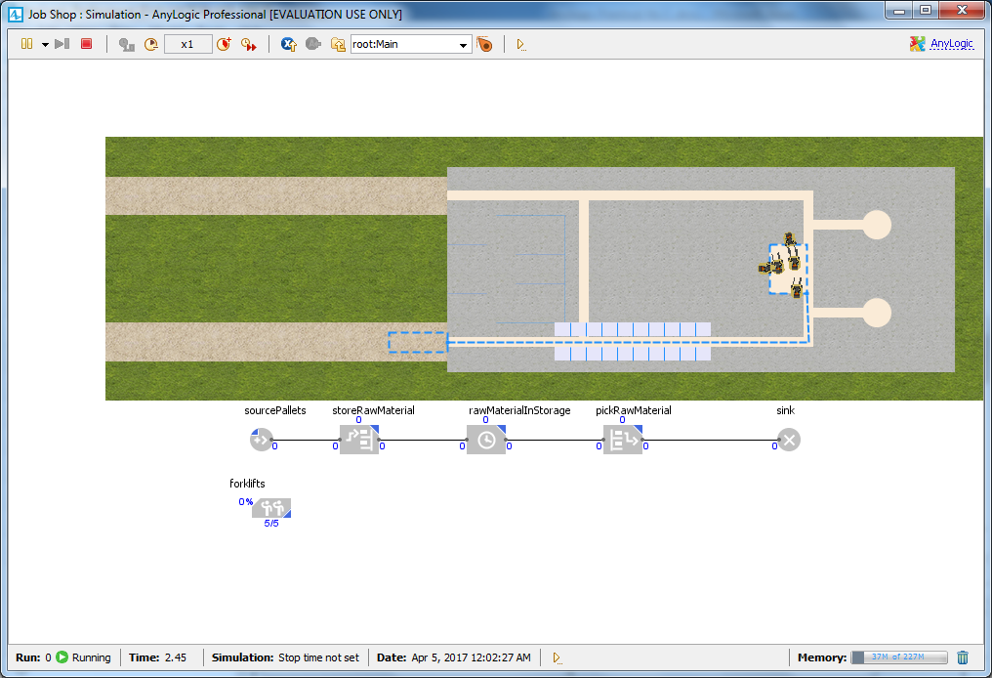

To switch to this 3D view, click the toolbar’s **Navigate to view area…** button and then click **[window3d]**.

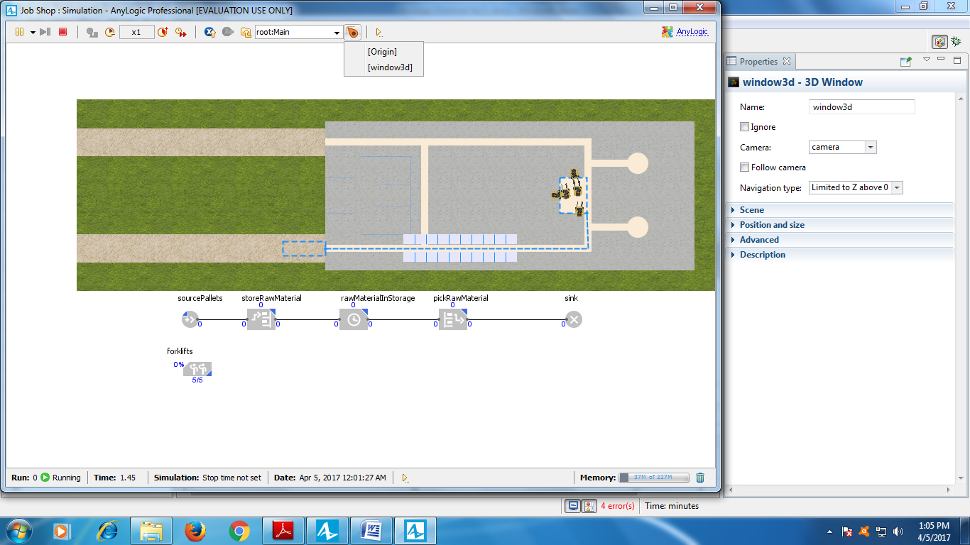

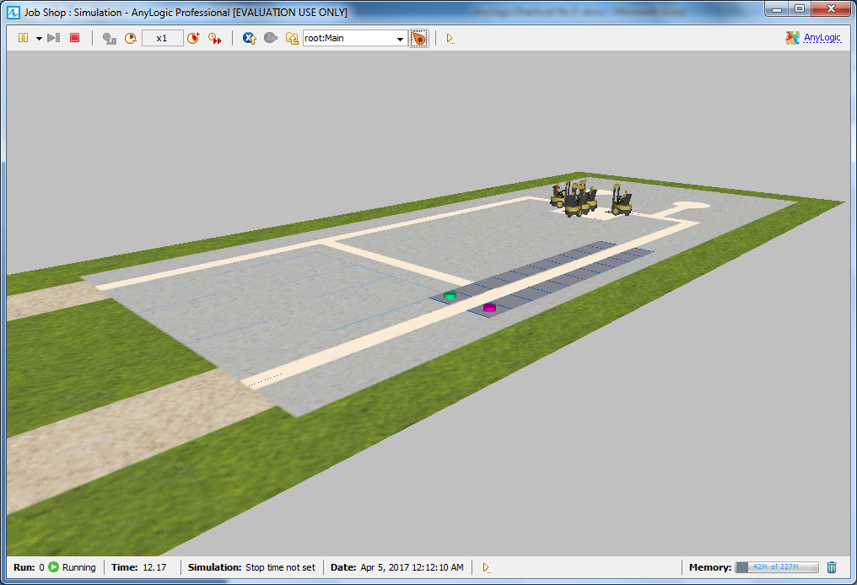

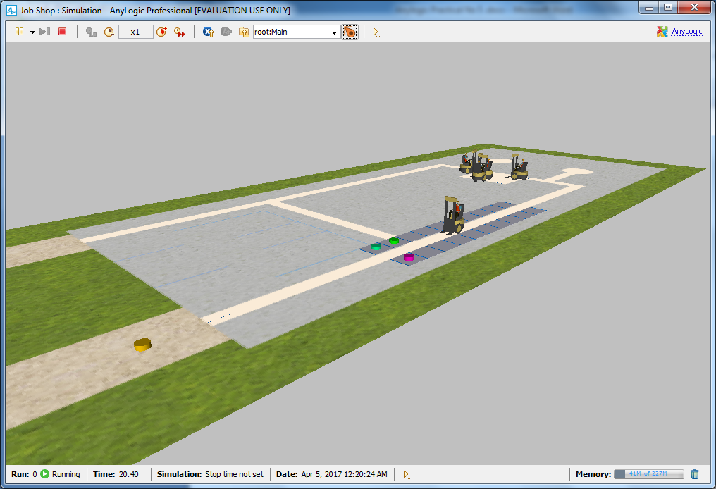

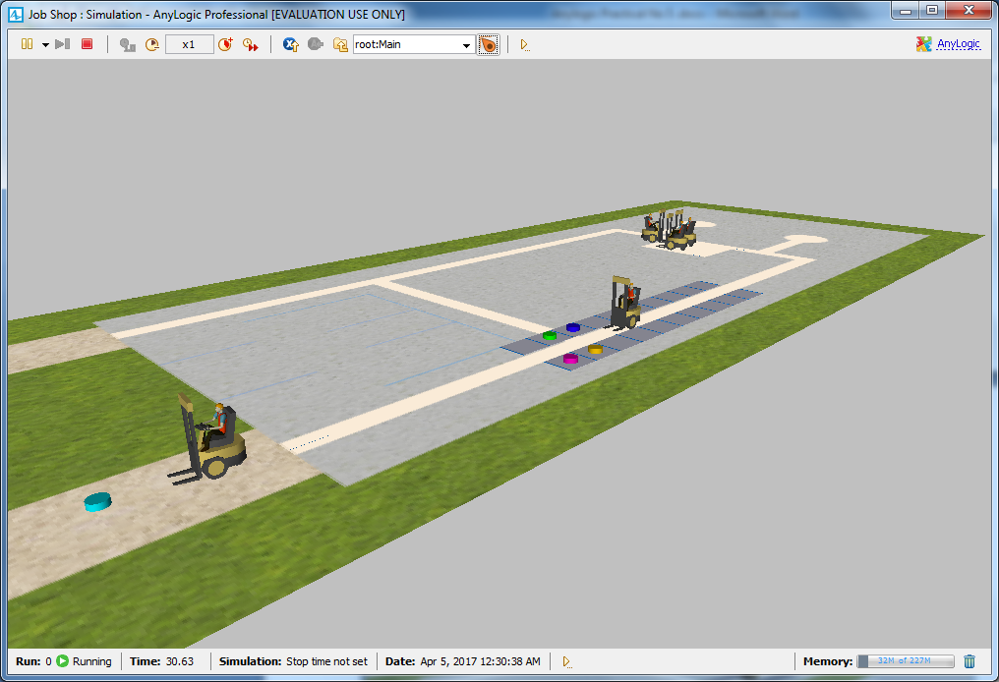

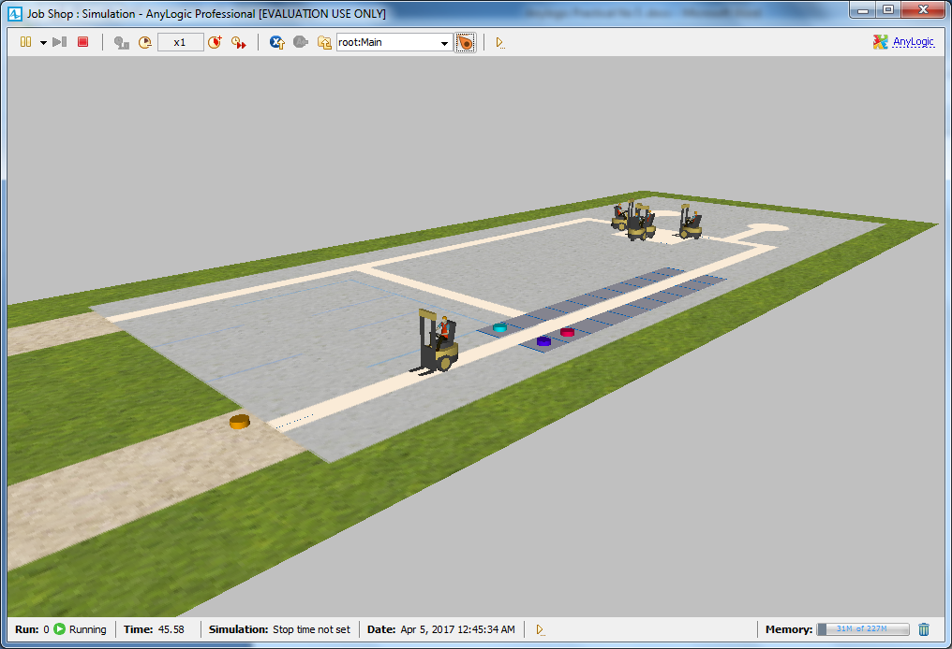

Do one or more of the following to navigate in 3D at runtime:

AnyLogic 7 in Three Days **161**

• To move the camera left, right, forward or backward, drag the mouse in

the selected direction.

• To move the camera closer to or further from the scene's center, rotate

the mouse’s wheel.

• To rotate the scene relative to the camera, drag the mouse while you

press and hold ALT and the left mouse button.

Choose the view you want to display at runtime, right-click

inside the 3D scene, and then click **Copy the camera’s location**.

Close the model’s window.

On the camera’s **Properties** area, apply the camera location you selected during

the previous step by clicking **Paste coordinates from clipboard**

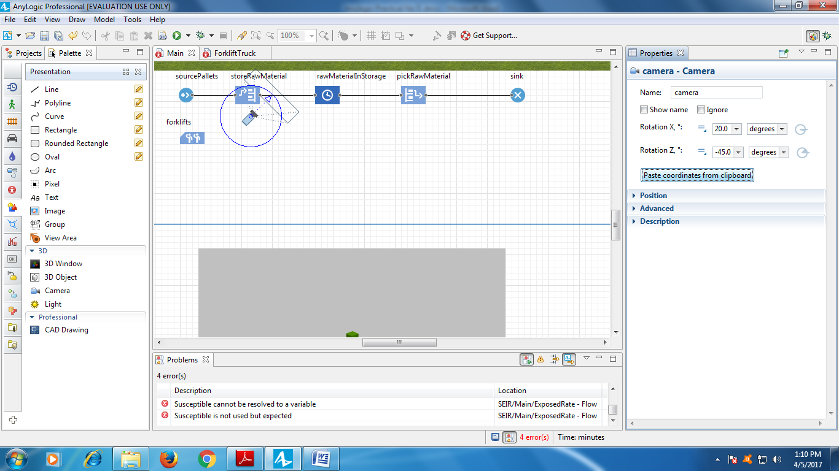

Run the model to view the 3D view from the new camera position, and then

close the model window.

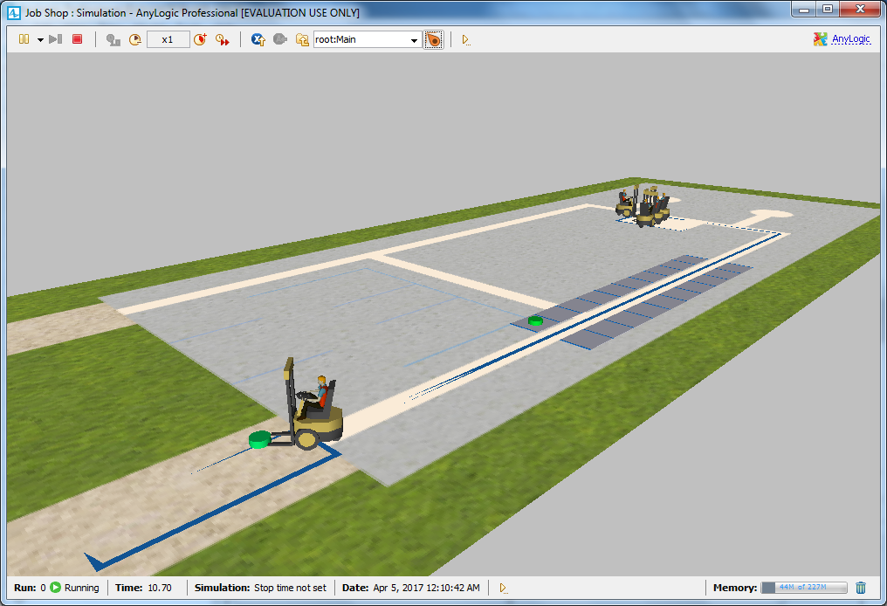

Expand the **Space Markup** palette’s **Pedestrian** area and then double-click the

**Wall** element’s icon to enable wall drawing mode.

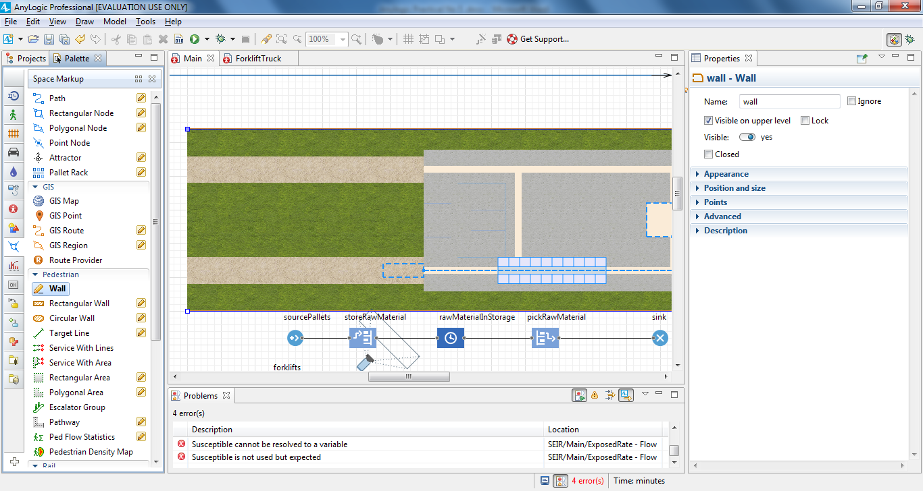

Do the following to draw walls around the job shop layout’s working area:

a. Click the position in the graphical editor where you want to start

drawing the wall.

b. Move the pointer in any direction to draw a straight line, and then

click at any point where you want to change direction.

c. Double-click at the point where you want to stop drawing the wall.

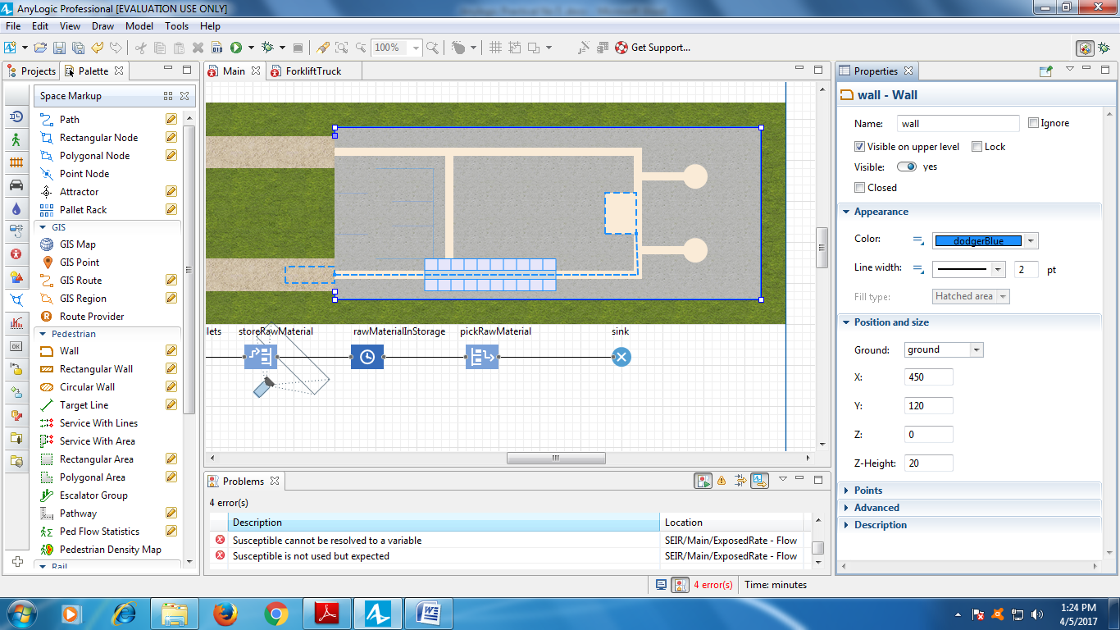

Do the following to change the wall’s fill color and texture:

a. On the wall’s **Properties** area, expand the **Appearance** section.

b. In the color menu, click **Other colors**.

c. In the **Colors** dialog, select the color that you want to apply to the

wall from the palette or the spectrum.

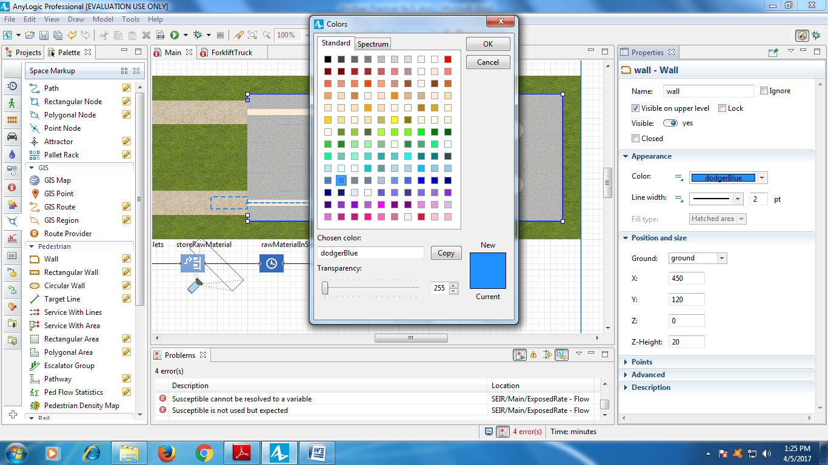

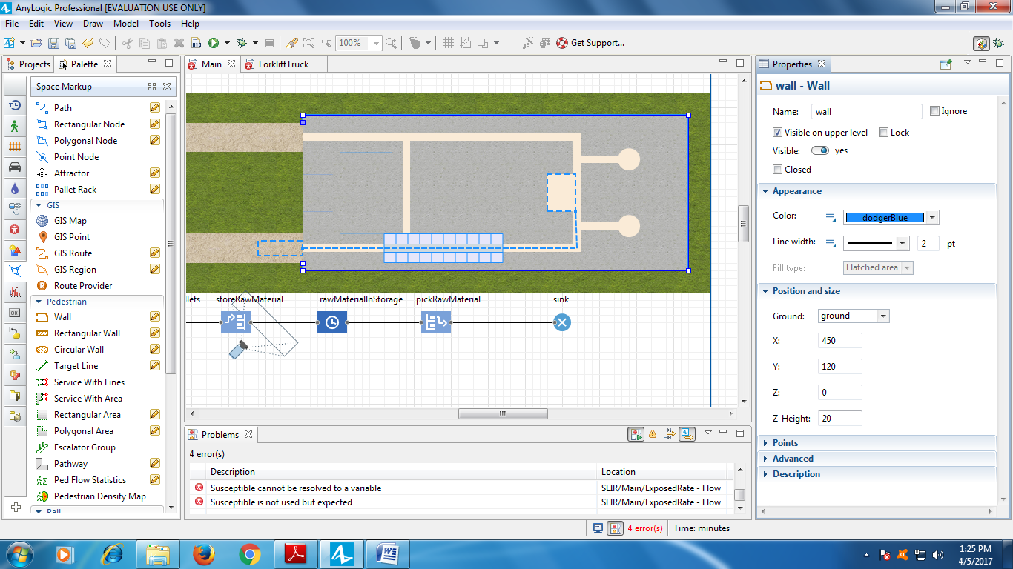

Go to the wall’s **Position and size** section and change the **Z-Height** to 40.

Draw another wall between the exits and then change the settings in the

second wall’s **Properties** area to match the first wall.

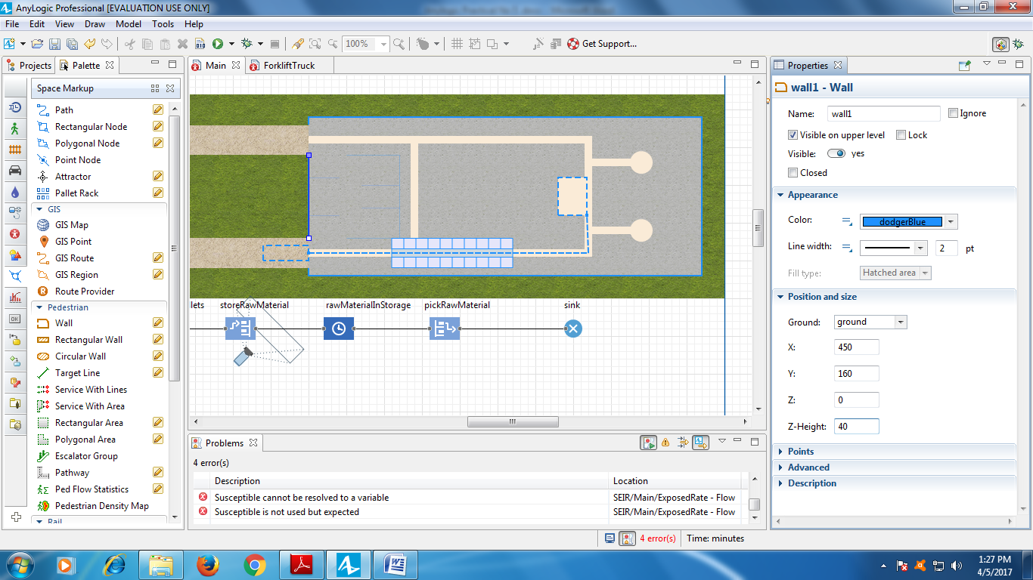

Run the model and view the 3D animation.

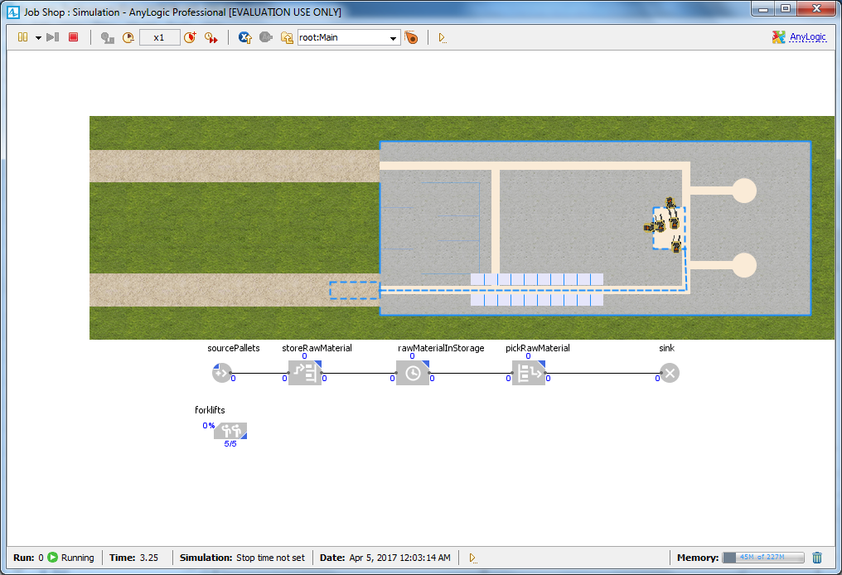

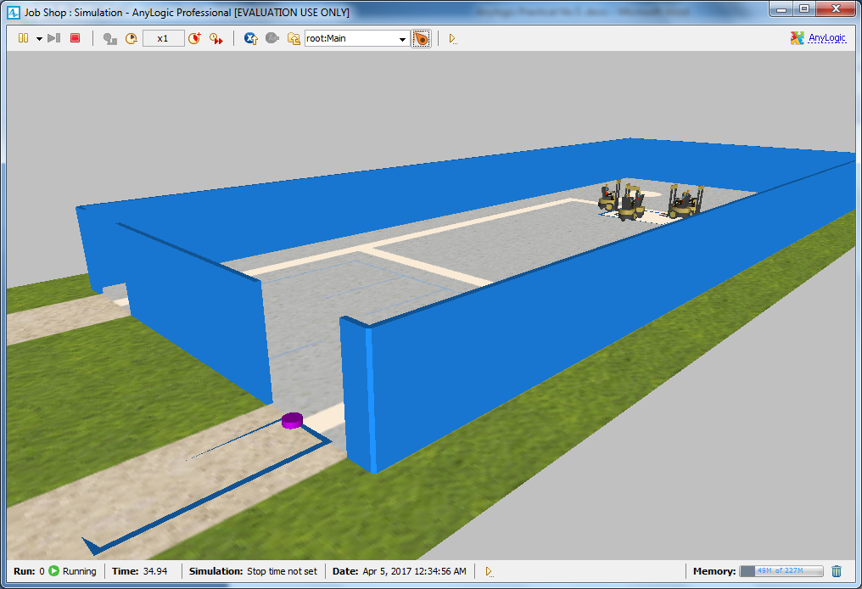

In the sourcePallets block’s **Properties** area, under the **New agent** list, click the

**create a custom type** link.

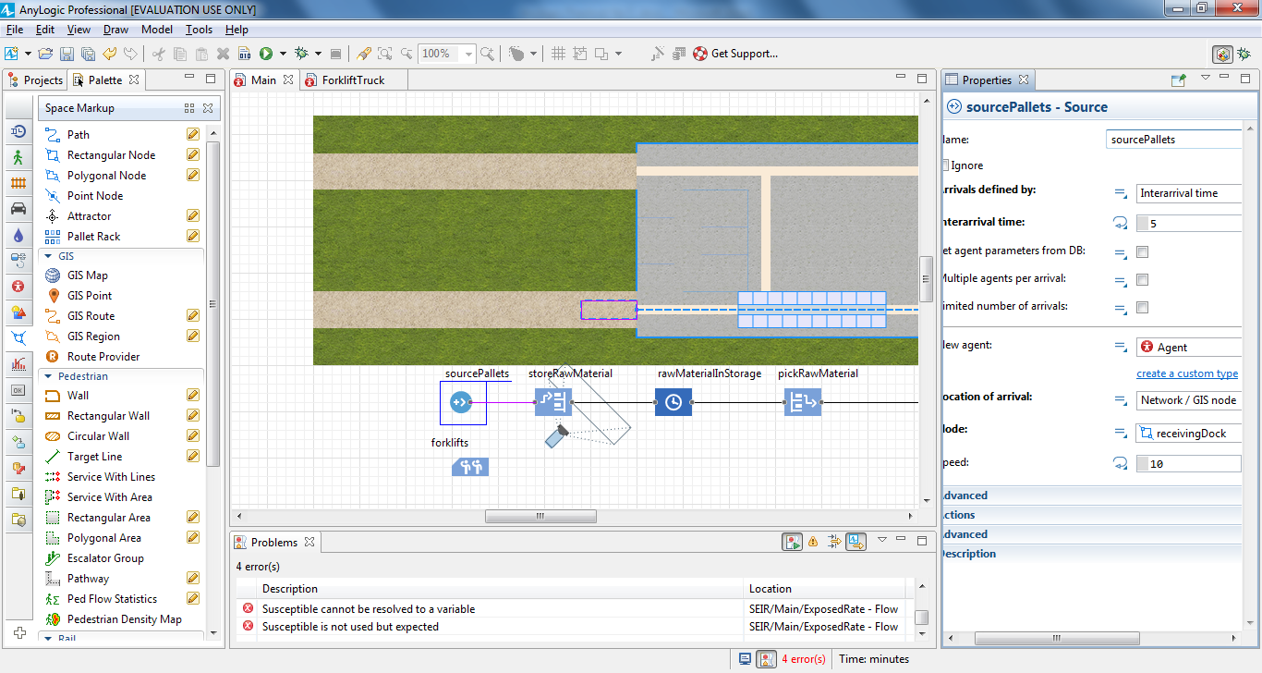

In the sourcePallets block’s **Properties** area, under the **New agent** list, click the

**create a custom type** link.

In the **New agent** wizard, do the following:

1. In the **Agent type name** field, type Pallet .
2. Click **Next**.

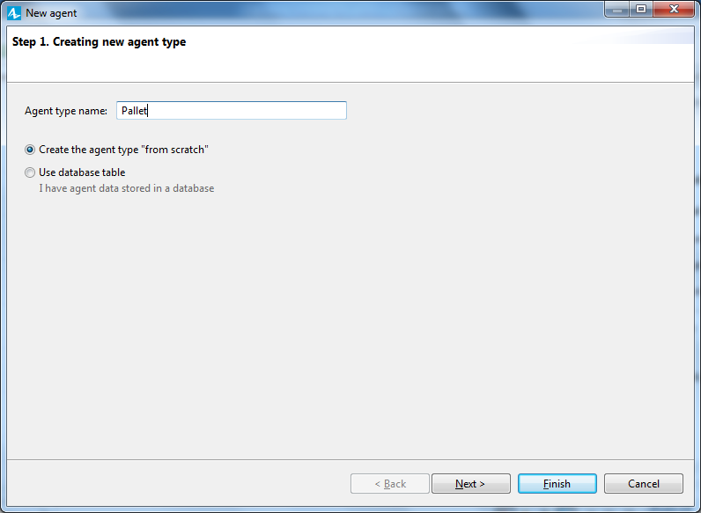

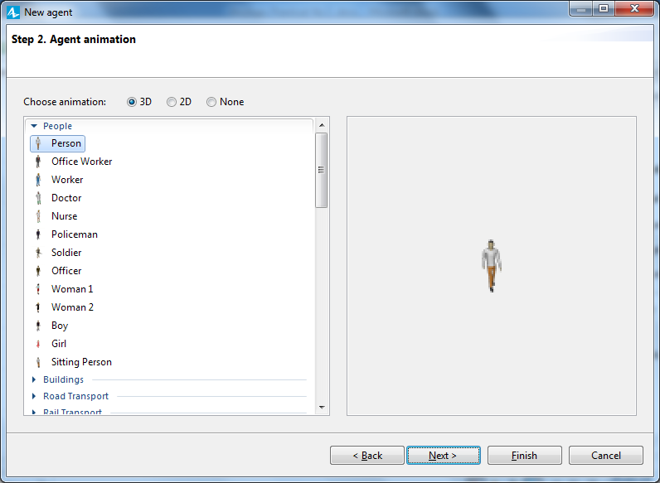

On the next page of the wizard, expand the **Warehouses and**

**Container Terminals** section in the list on the left, and then click the

3D animation figure **Pallet.**

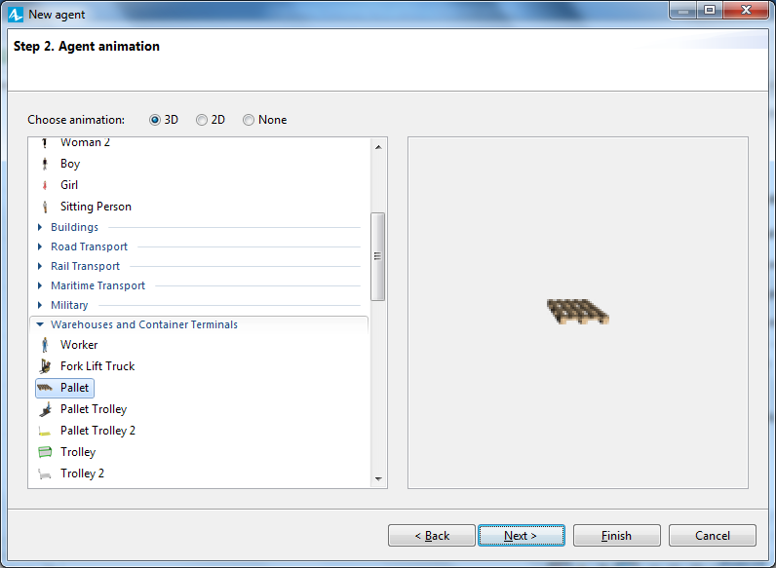

1. Click **Finish**.

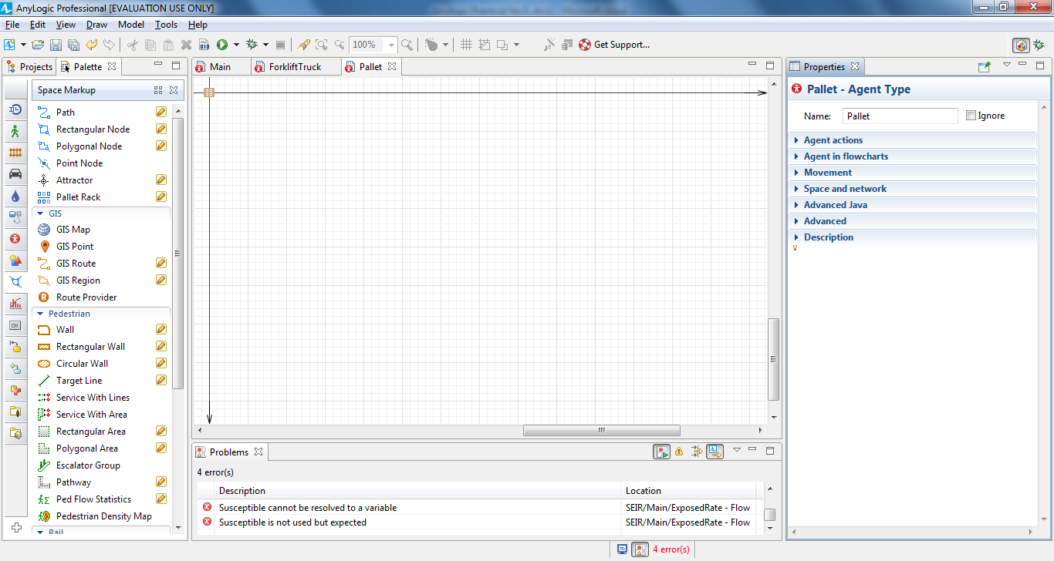

Using the **Zoom** toolbar, enlarge the Pallet diagram to 500%, and then move

the canvas to the right and down to view the axis’ origin point and pallet

animation shape.

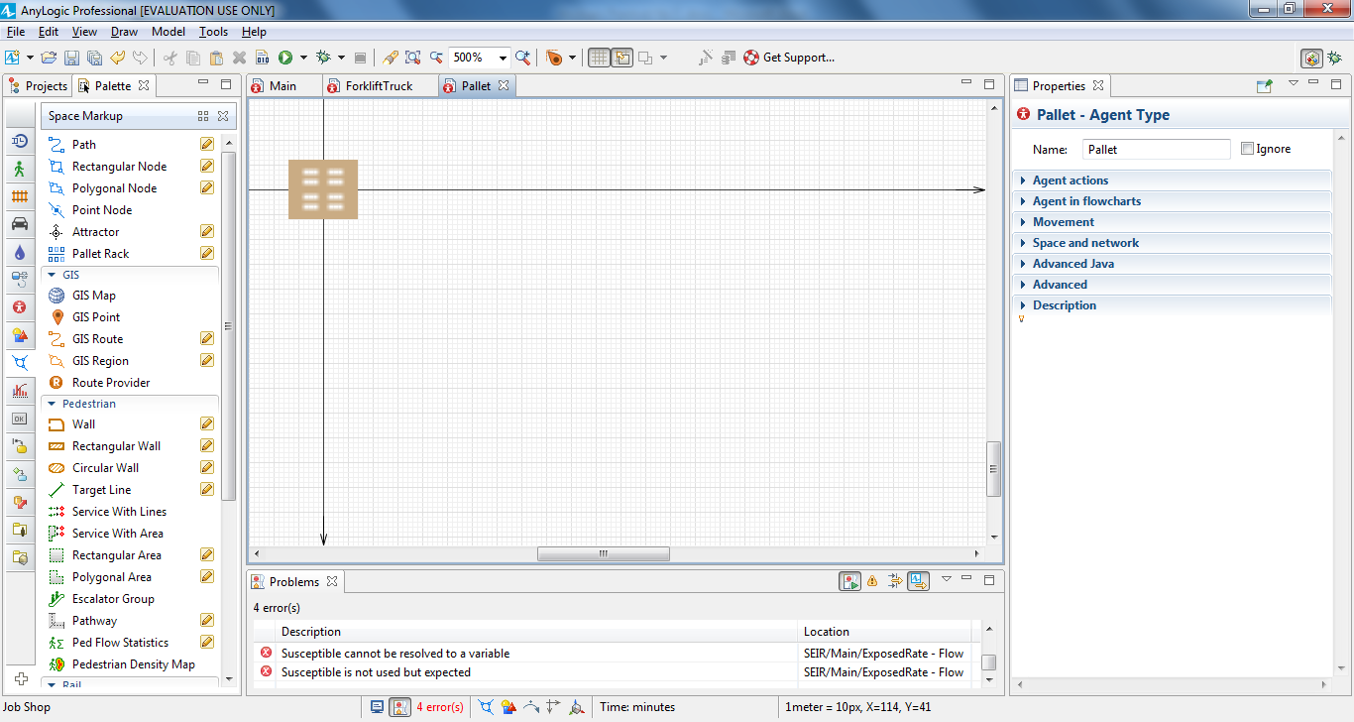

On the **3D Objects** palette, expand the **Boxes** area.

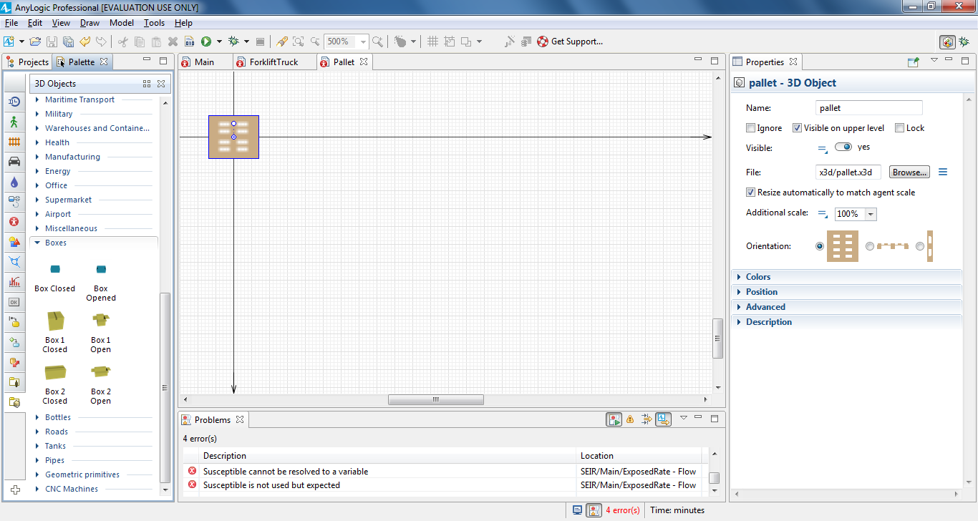

Drag the **Box 1 Closed** object on to the pallet’s upper-left corner.

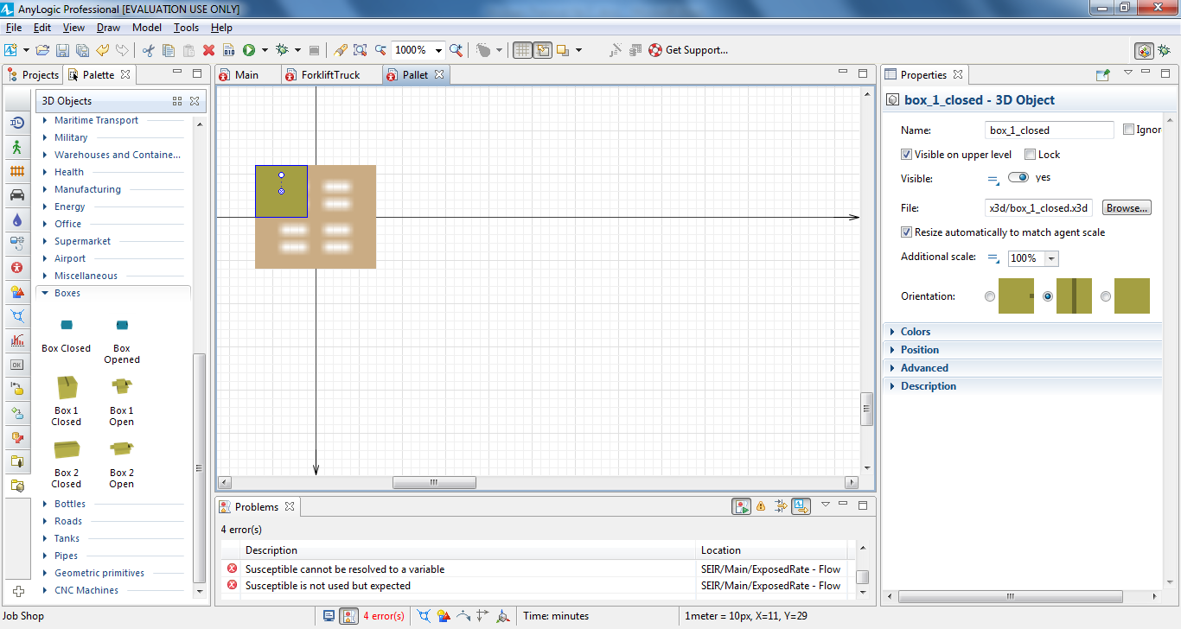

Since this box appears to be too large when compared to the pallet, let’s

change the box’s **Scale** to 75%.In the box’s **Properties** area, expand the **Position** section, and then change thebox’s **Z** coordinate to 2.

Our change reflects the fact that we want to place boxes on the pallets and

each pallet’s height is about 2 pixels.

**23.** Add three boxes by copying the first box three times. To copy the box, select it

and then press and hold CTRL as you drag the box.

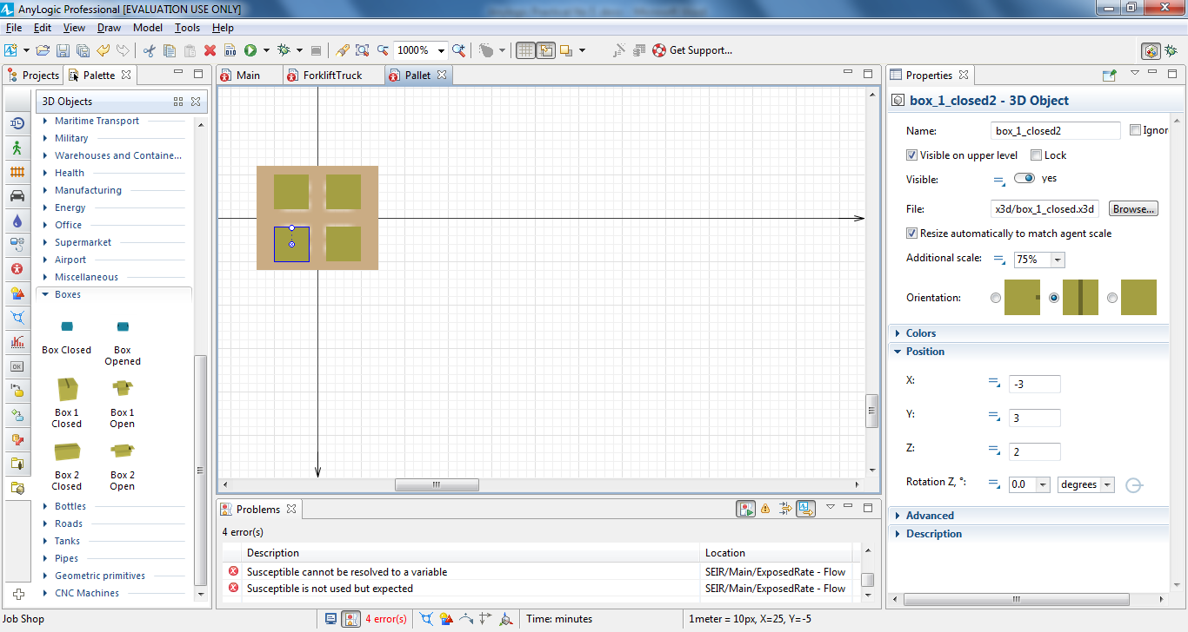

Our pallet now has four closed boxes, and you can now change the zoom level

back to 100% by clicking the toolbar’s **Zoom to 100%** button.

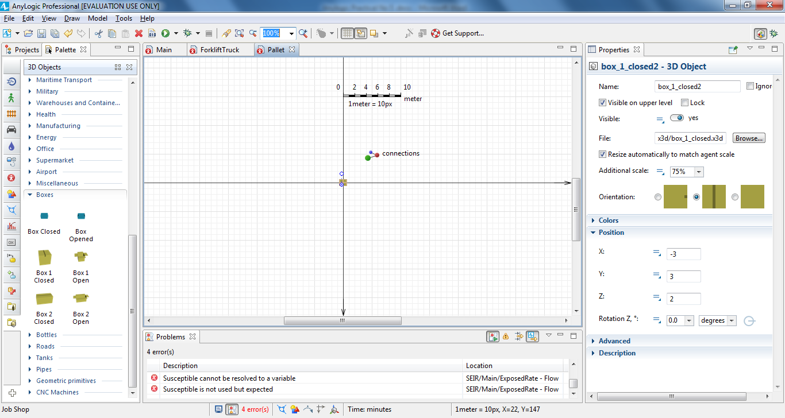

Return to the Main diagram.

If you open the sourcePallets block’s **Properties** area, you’ll see Pallet is selected as

**New agent**. This block will generate agents of the Pallet type.

Run the model.

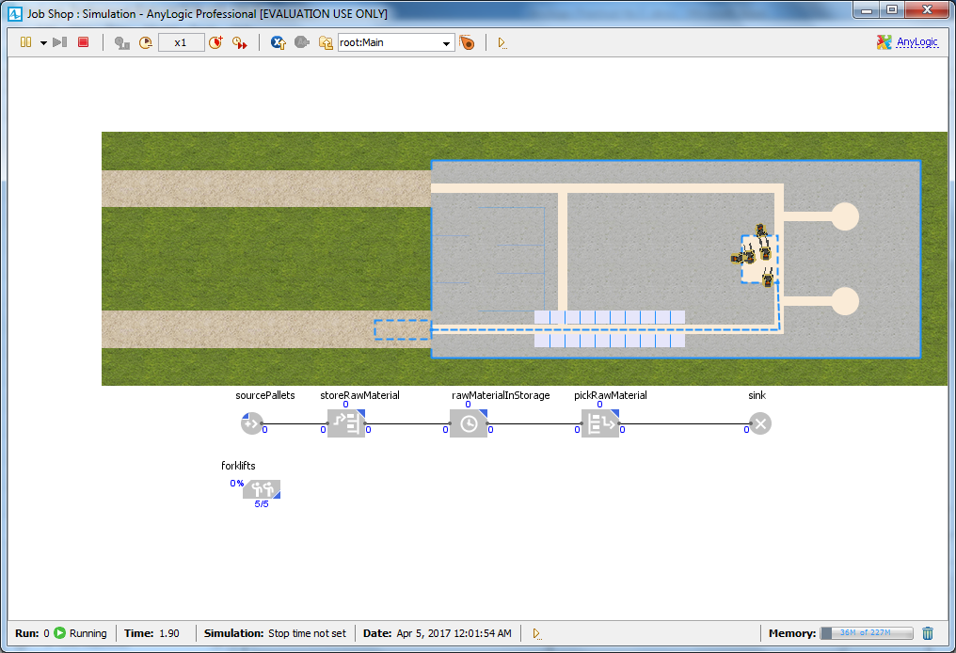

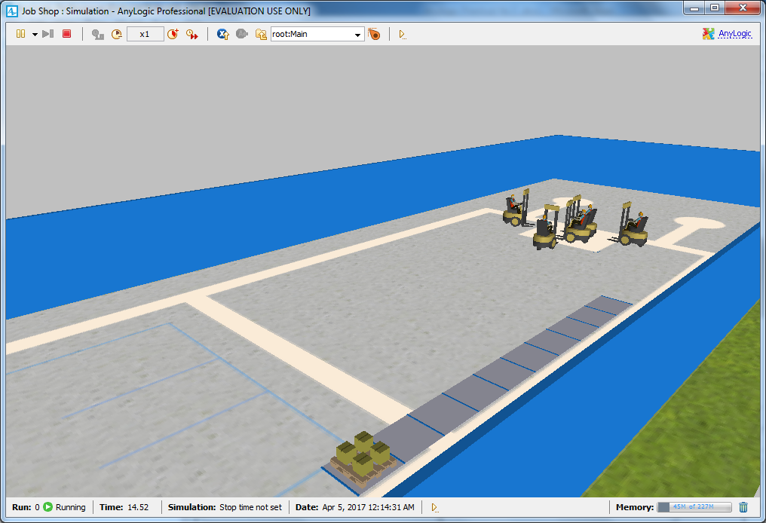

You’ll see pallet shapes have replaced the multicolored cylinders. However, if

you zoom in the 3D scene, you’ll notice that the forklift trucks aren’t

transporting pallets. We’ll correct this problem by moving our model’s pallet

animation in a way that allows the forklift trucks to pick up the pallets.

In the **Projects** view, double-click the ForkliftTruck agent type to open its

diagram and then move the forkliftWithWorker figure one cell to the right.

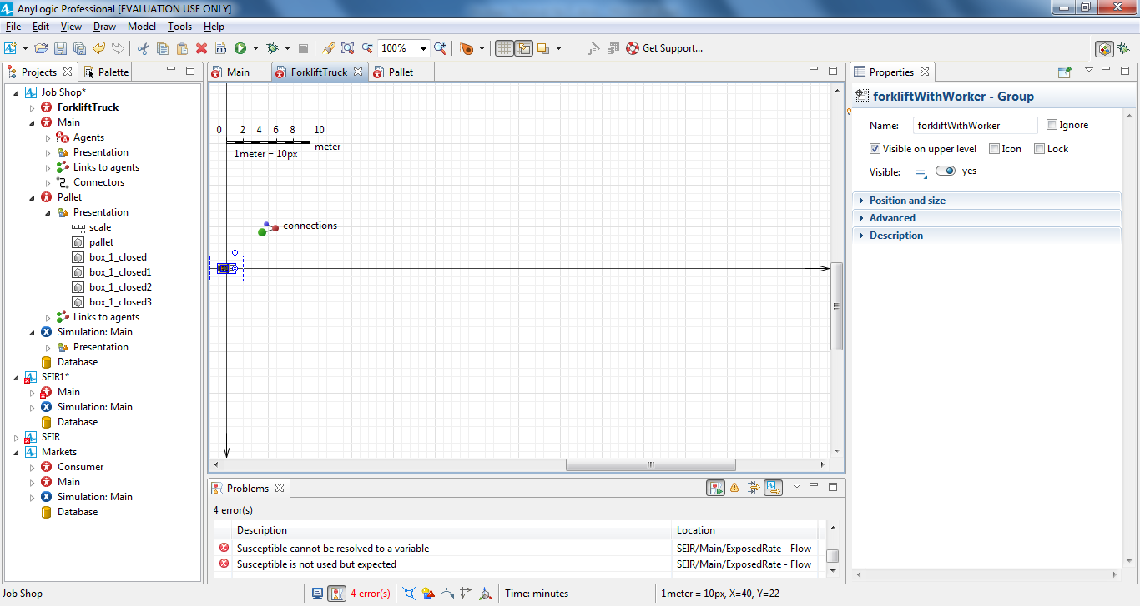

Open Main diagram, and in the pallet rack’s **Properties** area, in the **Number of**

**levels** box, type 2.

TIP: Remember that your first click will select the network and your second

click will select the network element.

**.** In the storeRawMaterial flowchart block’s **Properties** area, set the **Elevation**

**time per level** parameter to 30 **seconds**.

**.** In the pickRawMaterial block’s **Properties** area, set the **Drop time per level**

parameter to 30 **seconds**.

**.** Run the model and you’ll see a pallet rack with two levels.

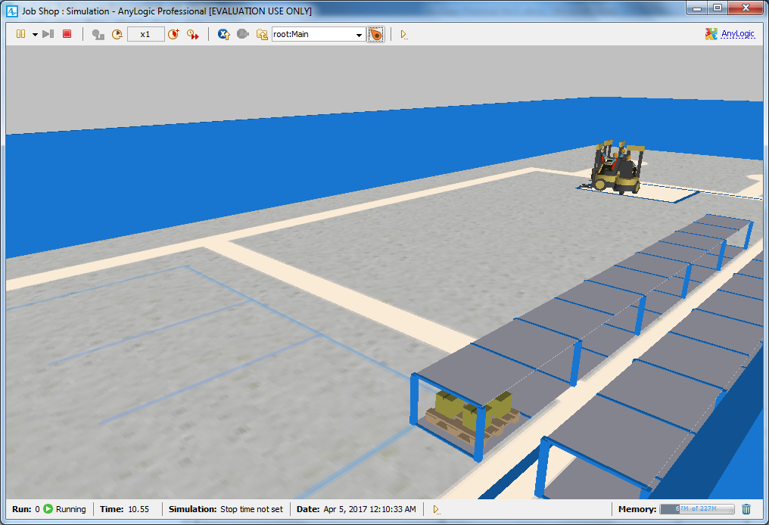

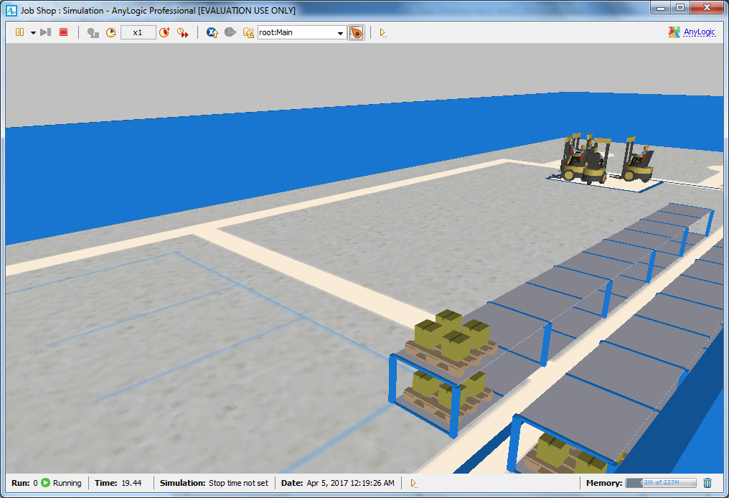

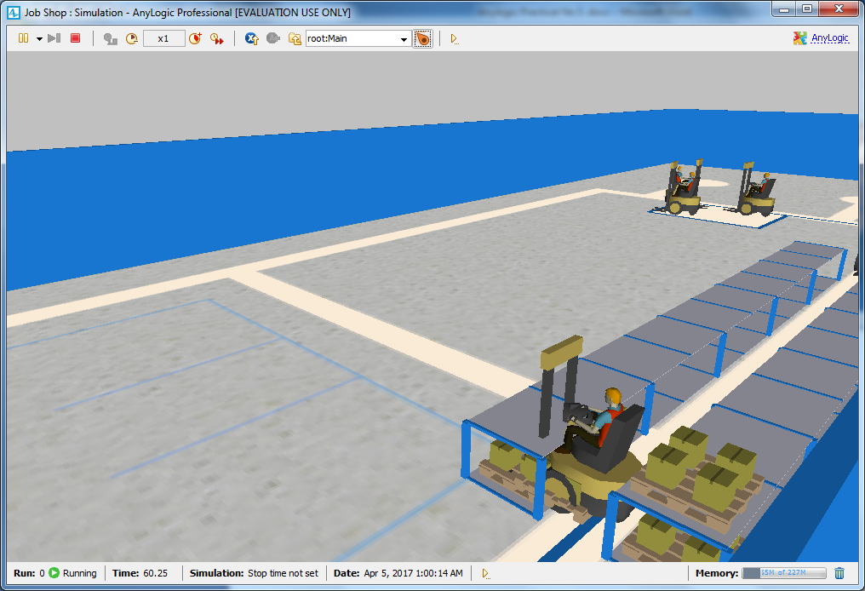

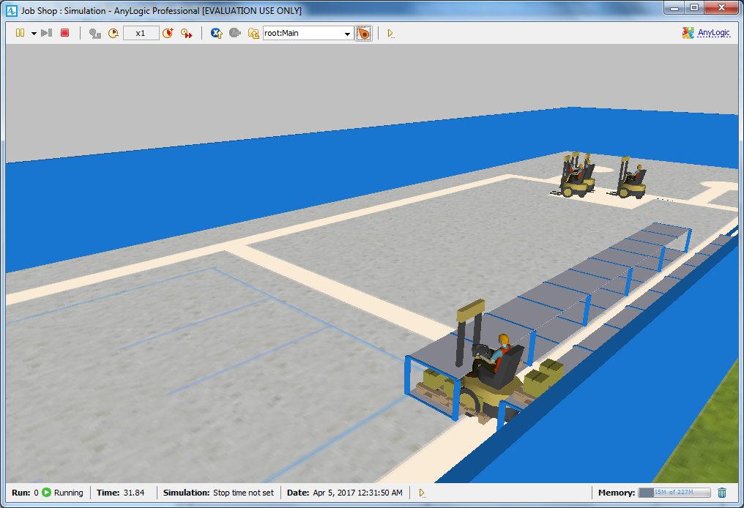

**Modeling pallet delivery by trucks**

On the **Process Modeling Library** palette, drag the **Agent Type** element on

to the Main diagram.

**2.** In the **New agent** wizard, do the following:

a. In the **Agent type name** box, type Truck.

b. Click **Next**.

c. On the next page of the wizard, expand the **Road Transport** section in the

list on the left, and then click the 3D animation figure **Truck.**

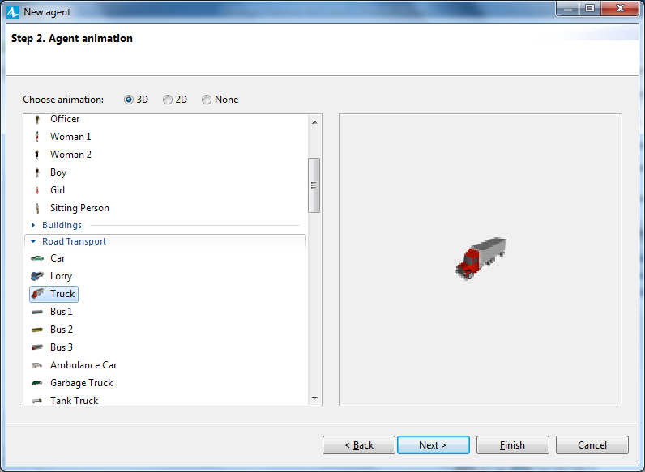

Click **Finish**.

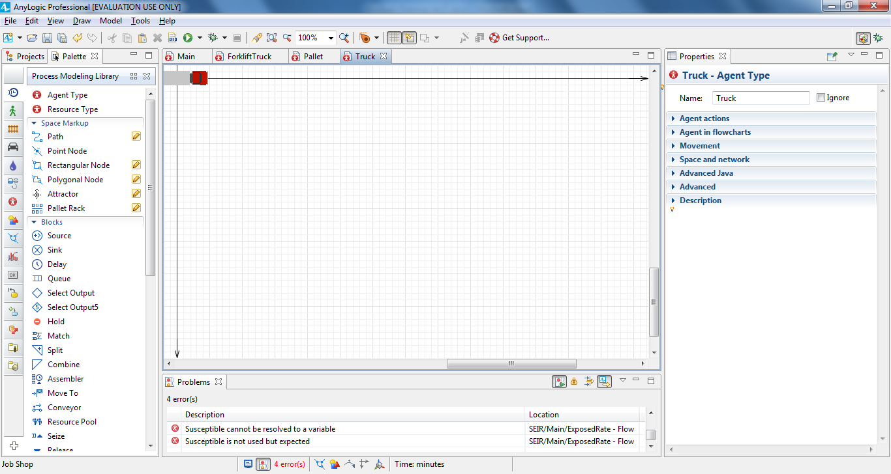

Open the Main diagram,

**4.** Under the **Space Markup** palette, click the **Point Node** element and drag it

on to the driveway entry.

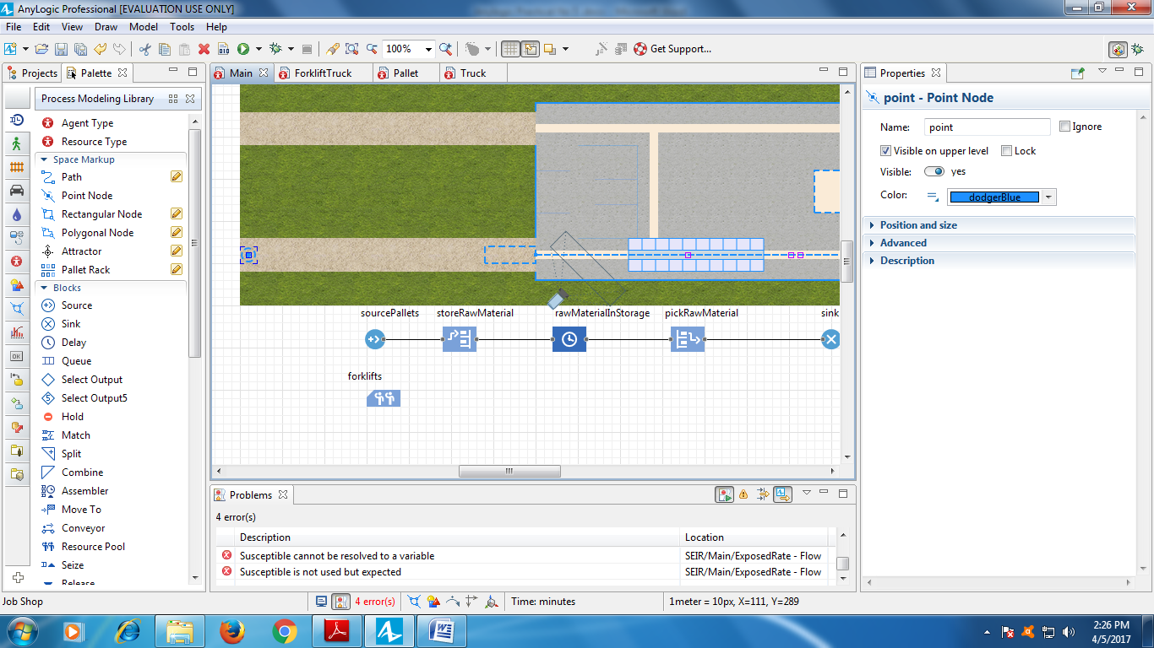

Name the node exitNode.

Draw a **Path** to connect the exitNode to the receivingDock.

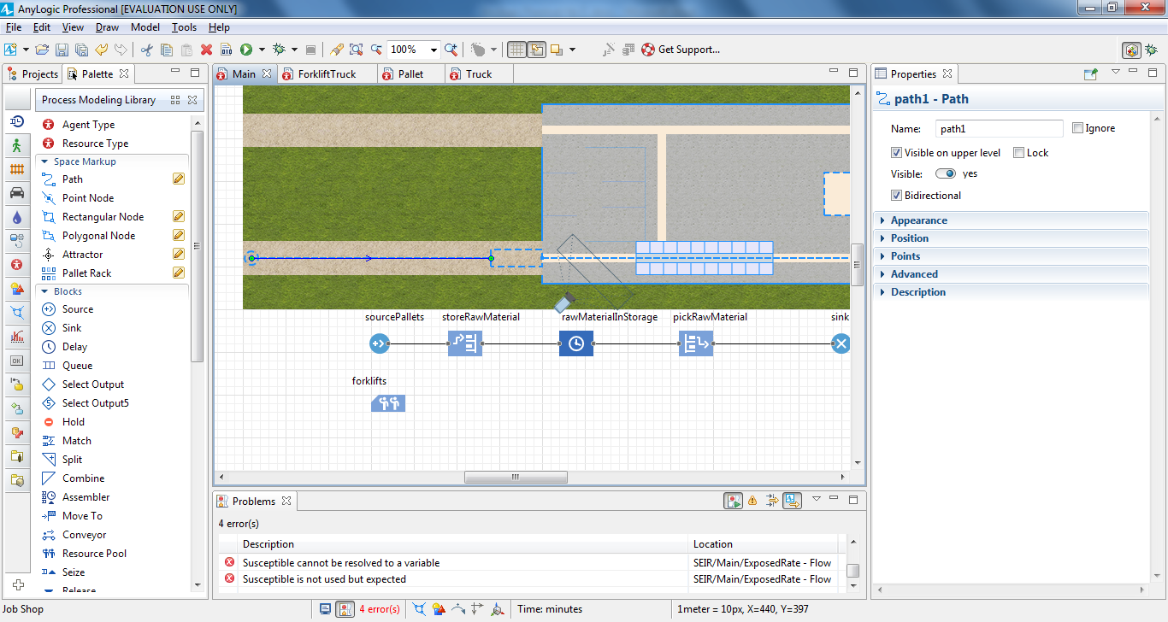

Make sure all space markup elements connect to one network.

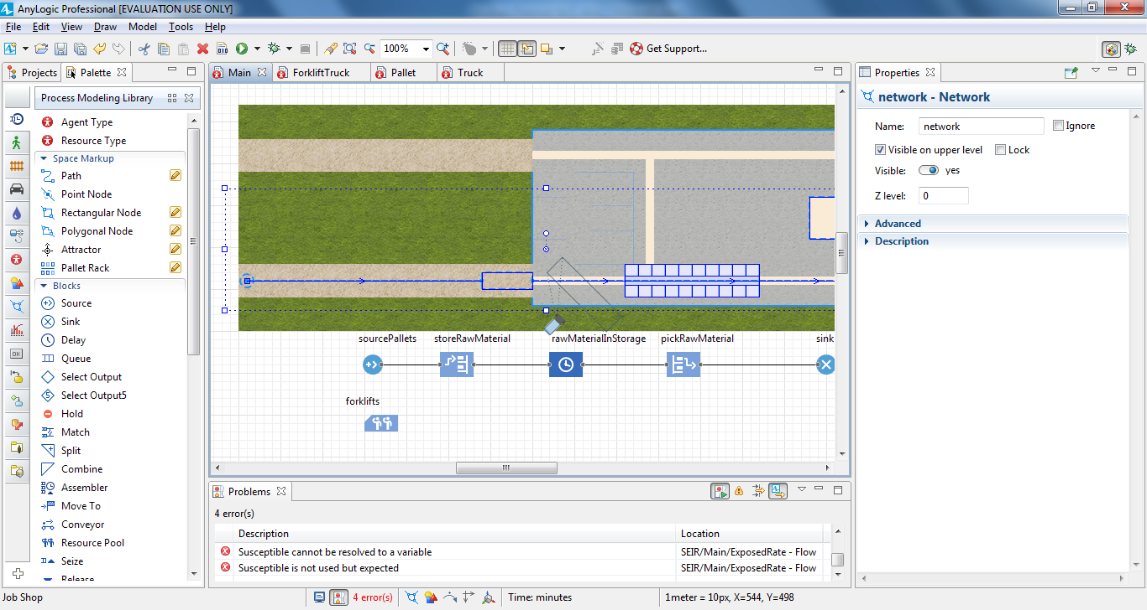

Create another process flowchart to define the truck movement logic by

connecting the **Process Modeling Library** blocks in the following order:

**Source** – **MoveTo** – **Delay** – **MoveTo** – **Sink**.

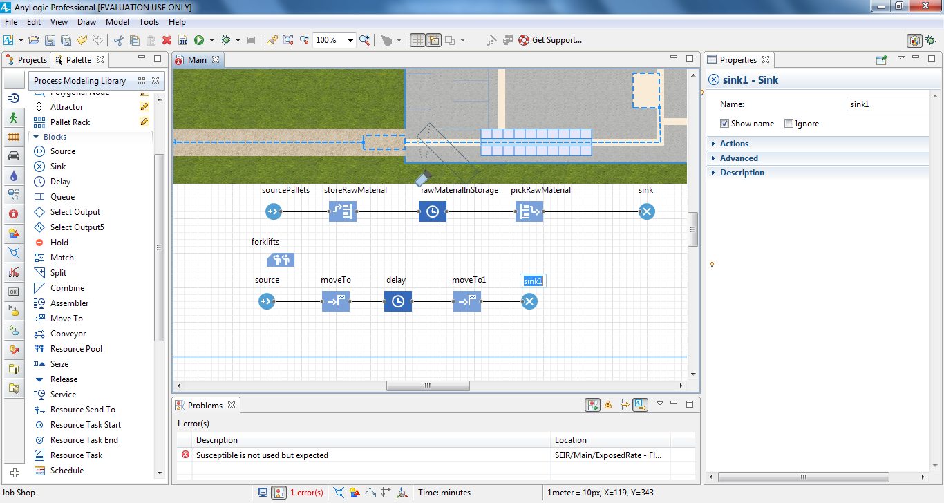

In the sourceDeliveryTrucks block’s **Properties** area, do the following to have a

new agent of the custom Truck type arrive to the driveway entry once per

hour at a specific speed:

a. In the **Arrivals defined by** list, click **Interarrival time**.

b. In the **Interarrival time** box, type 1, and select **hours** from the list on

the right.

c. In the **New agent** list, click **Truck**.

d. In the **Location of arrival** list, click **Network/GIS node**.

e. In the **Node** list, click **exitNode**.

f. In the **Speed** box, type 40, and select **kilometers per hour** from the

list on the right.

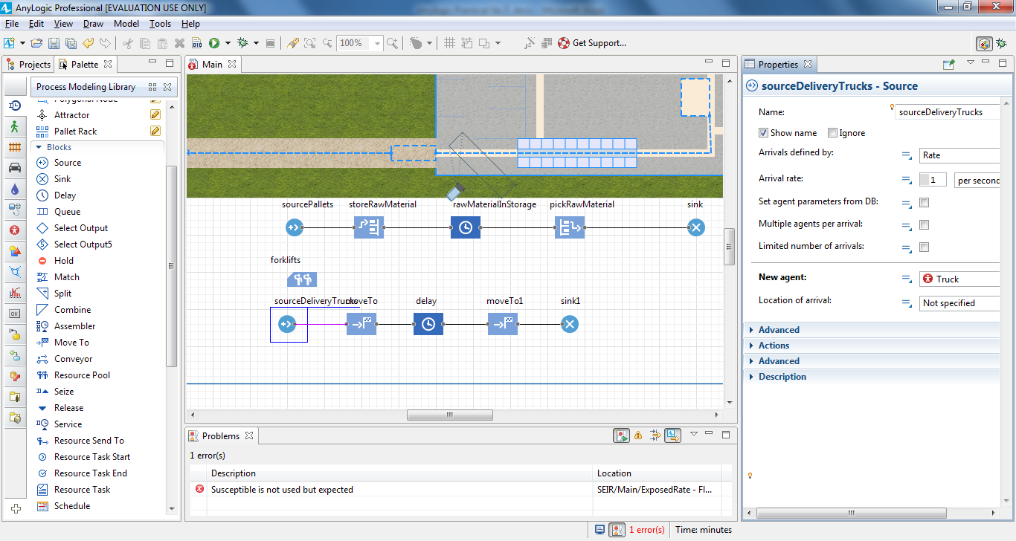

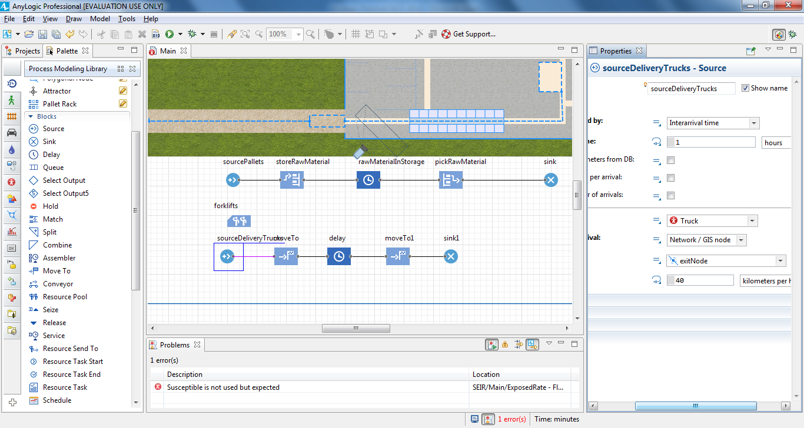

Name the first **MoveTo** block drivingToDock.

In the drivingToDock block’s **Properties** area, in the **Node** list, click

**receivingDock** to set the agent’s destination.

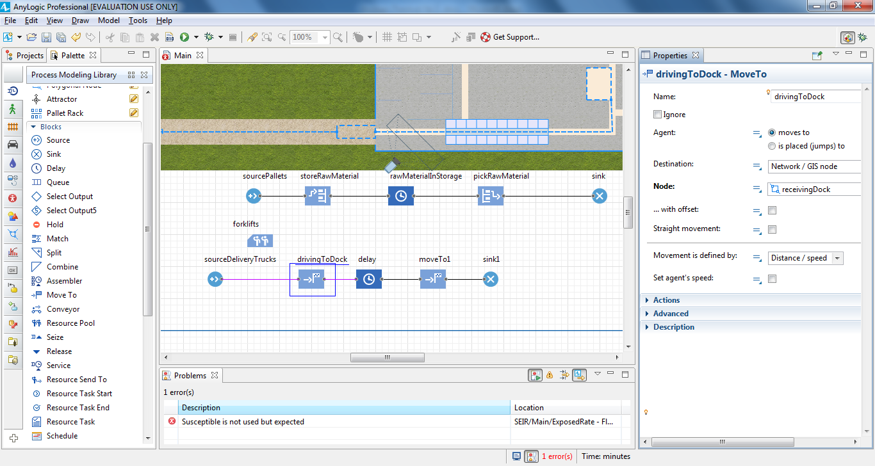

Rename the **Delay** block to unloading.

**13.** In the unloading block’s **Properties** area, do the following:

a. In the **Type** area, click **Until stopDelay() is called**.

b. In the **Agent location** list, click **receivingDock**.

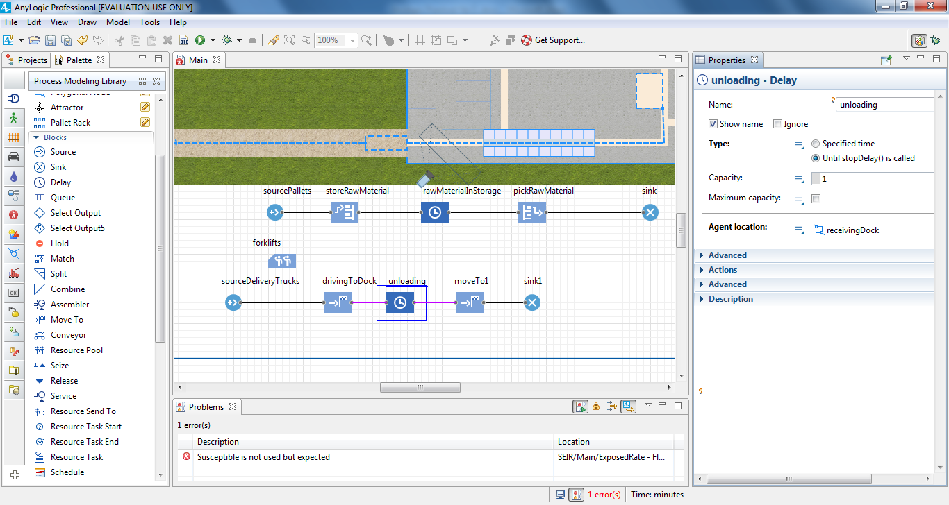

Name the second **MoveTo** block drivingToExit.

**15.** In the drivingToExit. block's **Properties** area, in the **Node** list, click **exitNode** to

set the destination node.

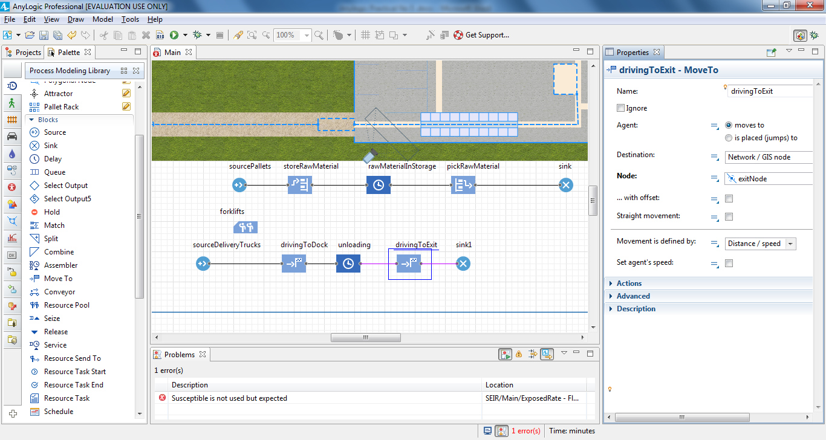

Our model’s two **Source** blocks generate two agent types: the trucks that appear

each hour and the pallet that is generated every five minutes. Since we want

pallets to appear when the truck unloads, we’ll change the arrival mode for the

**Source** block that generates them.

In the sourcePallets block's **Properties** area, in the **Arrivals defined by** list, click

**Calls of inject() function**.

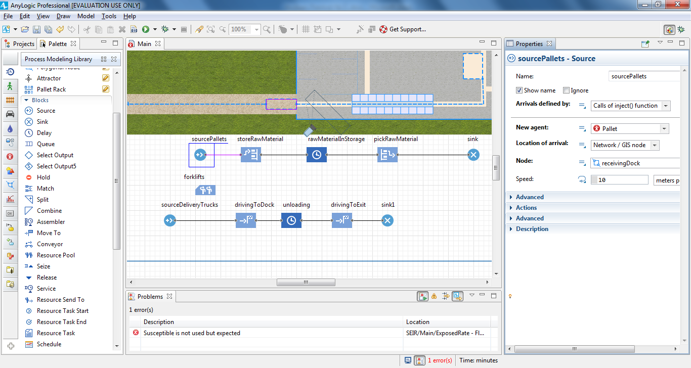

Do the following to have the sourcePallets block generate pallets when a truck

enters the unloading block:

a. In the unloading block’s **Properties** area, expand the **Actions** section.

b. In the **On enter** box, type the following:

sourcePallets.inject(16);

This Java function will ensure our model generates 16 pallets each time a

truck starts to unload.

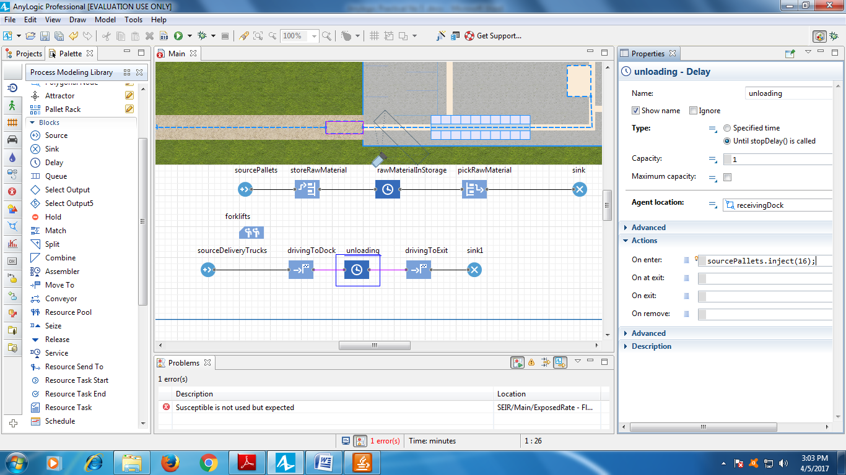

In the Main agent type’s **Properties** area, expand the **Agent actions** section and

then type the following Java function in the **On startup** box:

sourceDeliveryTrucks.inject(1);

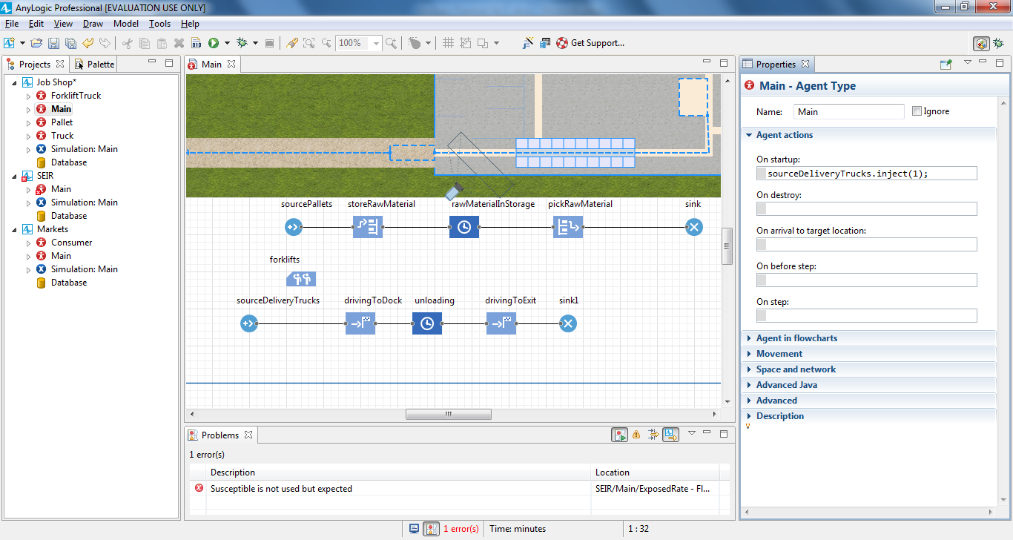

In the storeRawMaterial block’s **Properties** area, expand the **Actions** section,

and in the **On exit** box, type the following:

if( self.queueSize() == 0 )

unloading.stopDelayForAll();

In this example, self is a shortcut we use to refer to the block

storeRawMaterial from its own action.

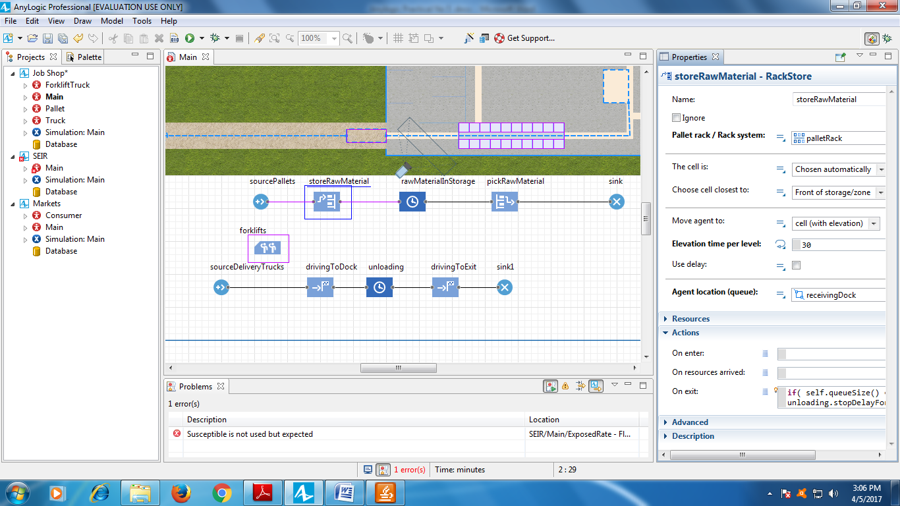

Run the model.

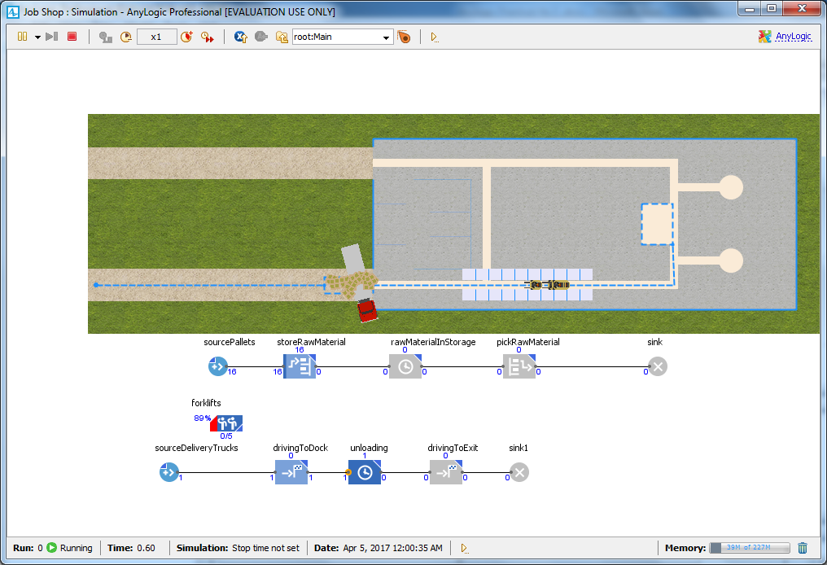

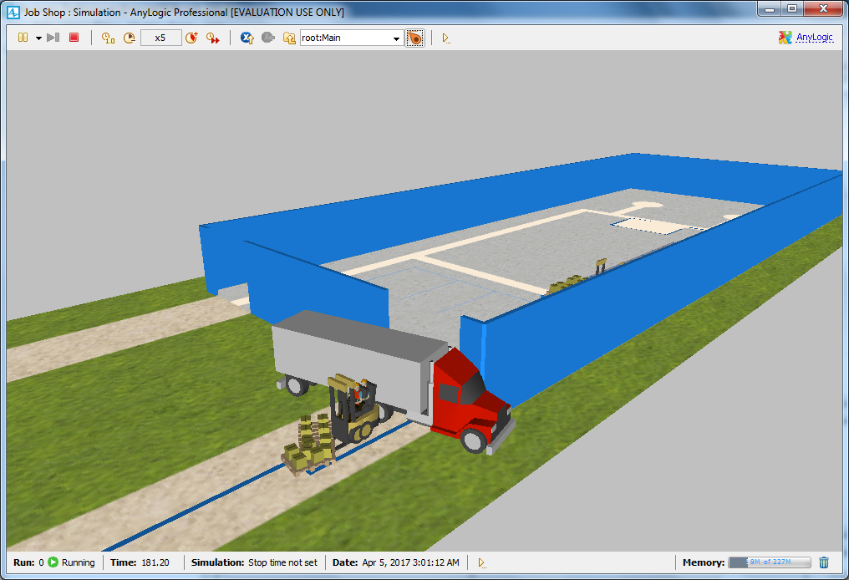

If the truck is aligned incorrectly as in the figure above, do the following to fix it.

In the **Projects** tree, double-click the **Truck** agent type to open its

diagram and view the truck animation figure.

b. In the graphical editor, select the truck shape and then use the round

handle or the **Rotation Z,°** property in the shape’s **Position** properties

area to rotate the truck to -180 degrees.

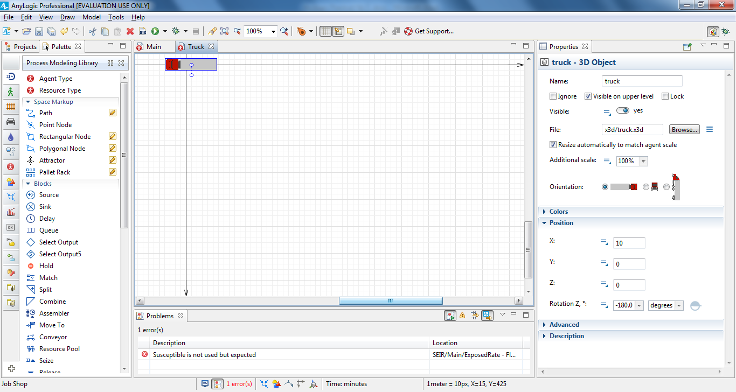

We’ve changed the truck figure’s position, but we’ll also need to change

AnyLogic’s default setting to make sure the program doesn’t rotate it a second

time.

Do the following to change AnyLogic’s default setting:

a. In the **Projects** area, click **Truck**.

b. On the Truck agent type’s **Properties** area, click the arrow to expand

the **Movement** area.

1. Clear the **Rotate animation towards movement** check box.

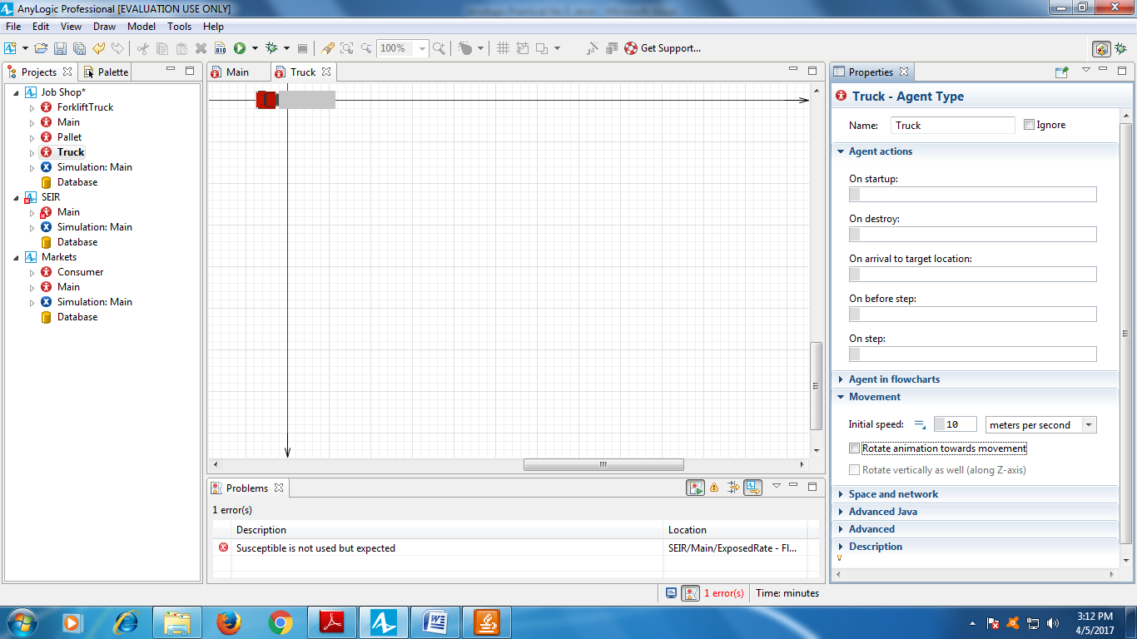

Open the Main diagram.

To ensure the pallets are correctly positioned in the receivingDock network

node, open the **Space Markup** palette, and drag an **Attractor** into

receivingDock. Let it face the entrance.

Run the model to check the truck behavior.

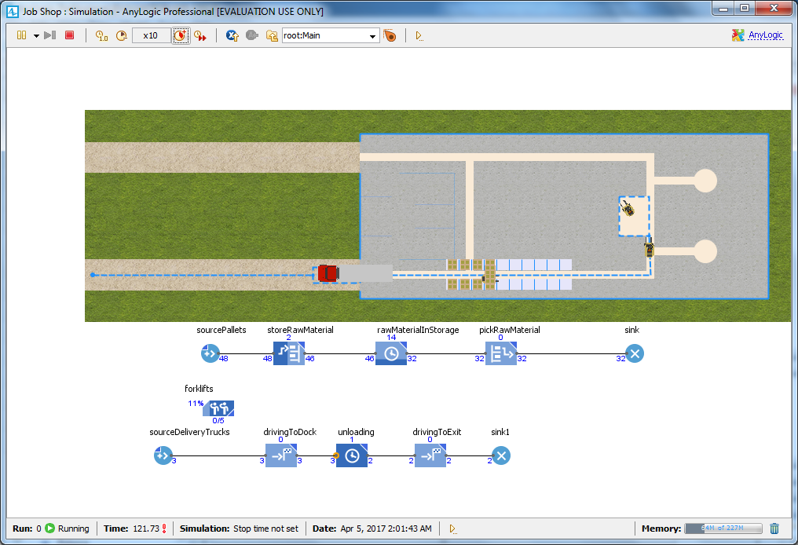

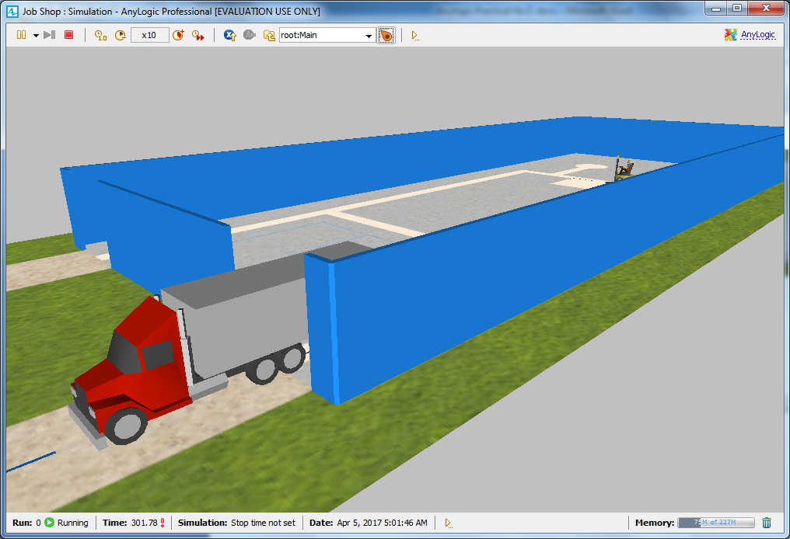

Removing the wall & checking the output

